# Once Upon a Map

# A Child’s Guide to Wardley Mapping Through Fairy Tales

### **WARNING: This content was generated using Generative AI. While efforts have been made to ensure accuracy and coherence, readers should approach the material with critical thinking and verify important information from authoritative sources.**

# Table of Contents

Introduction: The Magic of Maps 5

What is Wardley Mapping? 5

A simple explanation for children 5

Why maps are useful in business and life 5

How This Book Works 7

The structure of each chapter 7

How to use this book with children 8

Chapter 1: Hansel and Gretel’s Forest Adventure 10

The Story of Hansel and Gretel 10

A child-friendly retelling 10

Key elements of the story 10

Mapping Hansel and Gretel’s Journey 11

Identifying user needs 11

Mapping the components 12

Understanding evolution 14

Lessons from the Map 15

The importance of planning 15

Adapting to change 17

Finding your way home 18

Chapter 2: The Three Little Pigs’ Construction Project 20

The Tale of the Three Little Pigs 20

A simplified version for children 20

Important story elements 20

Mapping the Pigs’ Building Strategies 21

Identifying the pigs’ needs 21

Mapping building materials and methods 21

Exploring evolution in construction 24

Insights from the Map 25

The value of planning ahead 25

Balancing speed and quality 27

Learning from mistakes 28

Chapter 3: Cinderella’s Magical Transformation 31

The Story of Cinderella 31

A child-appropriate retelling 31

Key story components 31

Mapping Cinderella’s Journey 32

Identifying Cinderella’s needs 32

Mapping the magical elements 33

Understanding evolution in Cinderella’s world 35

Lessons from Cinderella’s Map 36

The power of transformation 36

Recognising opportunities 38

The importance of timing 39

Chapter 4: Jack’s Beanstalk Business Venture 42

The Tale of Jack and the Beanstalk 42

A child-friendly version 42

Important elements of the story 42

Mapping Jack’s Adventure 44

Identifying Jack’s needs 44

Mapping the components of Jack’s journey 45

Exploring evolution in Jack’s world 47

Insights from Jack’s Map 48

Taking calculated risks 48

The value of unique resources 50

Balancing ethics and opportunity 50

Conclusion: Your Own Fairy Tale Map 53

Recap of Mapping Principles 53

Key elements of a Wardley Map 53

How to apply mapping to any story 54

Creating Your Own Fairy Tale Map 55

Choosing a favourite story 55

Step-by-step guide to mapping 55

Sharing and discussing your map 55

The Future of Your Mapping Adventure 55

Using mapping in everyday life 55

Continuing to learn and grow 55

Appendix: Book Generation Details 56

Appendix: Further Reading on Wardley Mapping 57

Core Wardley Mapping Series 57

Practical Resources 60

Specialized Applications 61

# Introduction: The Magic of Maps

## What is Wardley Mapping?

### A simple explanation for children

Imagine you’re going on a treasure hunt in a big, mysterious forest. You wouldn’t want to go without a map, would you? Wardley Mapping is like creating a special map for grown-ups to find treasure in the world of business!

Just like how a regular map shows you where mountains, rivers, and cities are, a Wardley Map shows important things in a business. It helps people understand what they need, what they have, and how things might change over time.

* What customers want (like ice cream on a hot day)
* Things needed to make customers happy (like ice cream ingredients)
* How these things might change (like new flavours being invented)

By using Wardley Maps, grown-ups can make better decisions about their business, just like how you might use a map to decide the best way to get to the playground!

A wise business leader once said, ‘A good map is worth a thousand guesses.’

### Why maps are useful in business and life

Wardley Mapping is like drawing a magical treasure map for your ideas and plans! Just as a pirate’s map shows where the treasure is buried and how to get there, a Wardley Map helps us understand how different parts of a business or project work together.

Imagine you’re building a giant sandcastle. You need to know what parts you need (like towers, walls, and a moat), how they fit together, and which ones are most important. A Wardley Map is like a special drawing that shows all of this information in one place.

* It shows what you need (like sand and water for your castle)
* It shows how things are connected (like how the towers support the walls)
* It shows what might change over time (like how the tide might affect your moat)

By using Wardley Maps, even children can learn to think like clever business leaders or creative inventors. It helps us make better decisions and come up with amazing new ideas!

‘A good map is worth a thousand guesses,’ as a wise business leader once said.

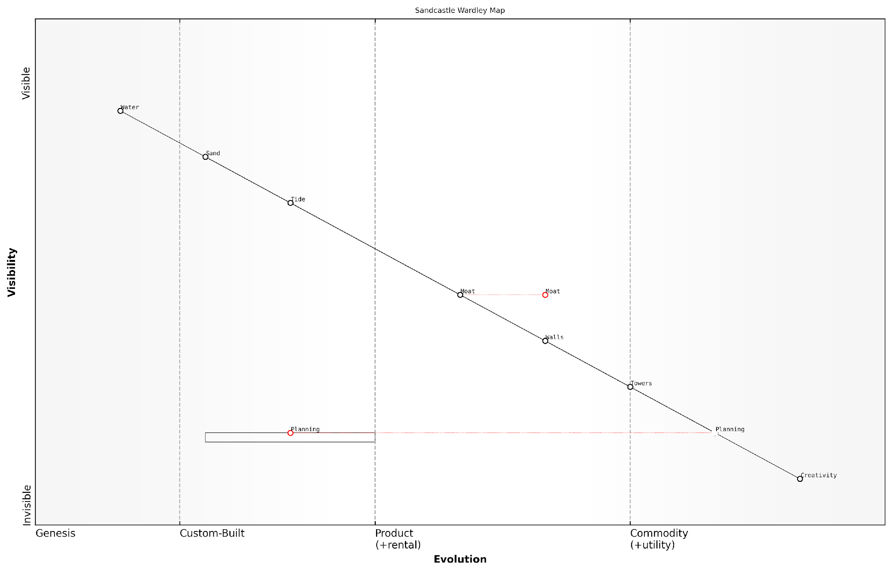

*Draft Wardley Map: [Insert Wardley Map: Why maps are useful in business and life]*

[Edit this draft Wardley Map](https://create.wardleymaps.ai/#clone:bf2d98d9ea72ae1d30)

Wardley Map Assessment

This Wardley Map effectively illustrates the strategic components and relationships involved in building a sandcastle, serving as a powerful metaphor for business and life strategies. It highlights the critical role of creativity and planning in driving value, while also emphasising the importance of efficient resource utilisation and adaptability to external factors. The map suggests opportunities for innovation in both high-value (Creativity, Planning) and evolving (Moat) components, while also indicating potential risks from external factors (Tide) and resource dependencies. To maximise strategic advantage, focus should be placed on fostering a culture of creativity, optimising planning processes, and developing adaptive strategies to mitigate external risks. The map’s unique inclusion of Creativity as a key component and consideration of external factors provides valuable insights for strategic planning across various domains.

[View full Wardley Map report](http://markdown_wardley_map_reports/wardley_map_report_02_Why_maps_are_useful_in_business_and_life.md)

## How This Book Works

### The structure of each chapter

Each chapter in this book follows a consistent structure to help young readers easily navigate and understand the concepts of Wardley Mapping through fairy tales.

* Story Introduction: A child-friendly retelling of a classic fairy tale
* Key Elements: Highlighting important aspects of the story for mapping
* Mapping Exercise: Guiding readers through creating a Wardley Map based on the story
* Lessons and Insights: Exploring what we can learn from the map
* Fun Activities: Engaging exercises to reinforce learning

This structure allows children to start with familiar stories and gradually build their understanding of Wardley Mapping principles. By the end of each chapter, readers will have created their own map and gained valuable insights into strategic thinking.

A well-known educator once said, ‘The best way to learn is through stories and play.’ This book aims to do just that with Wardley Mapping.

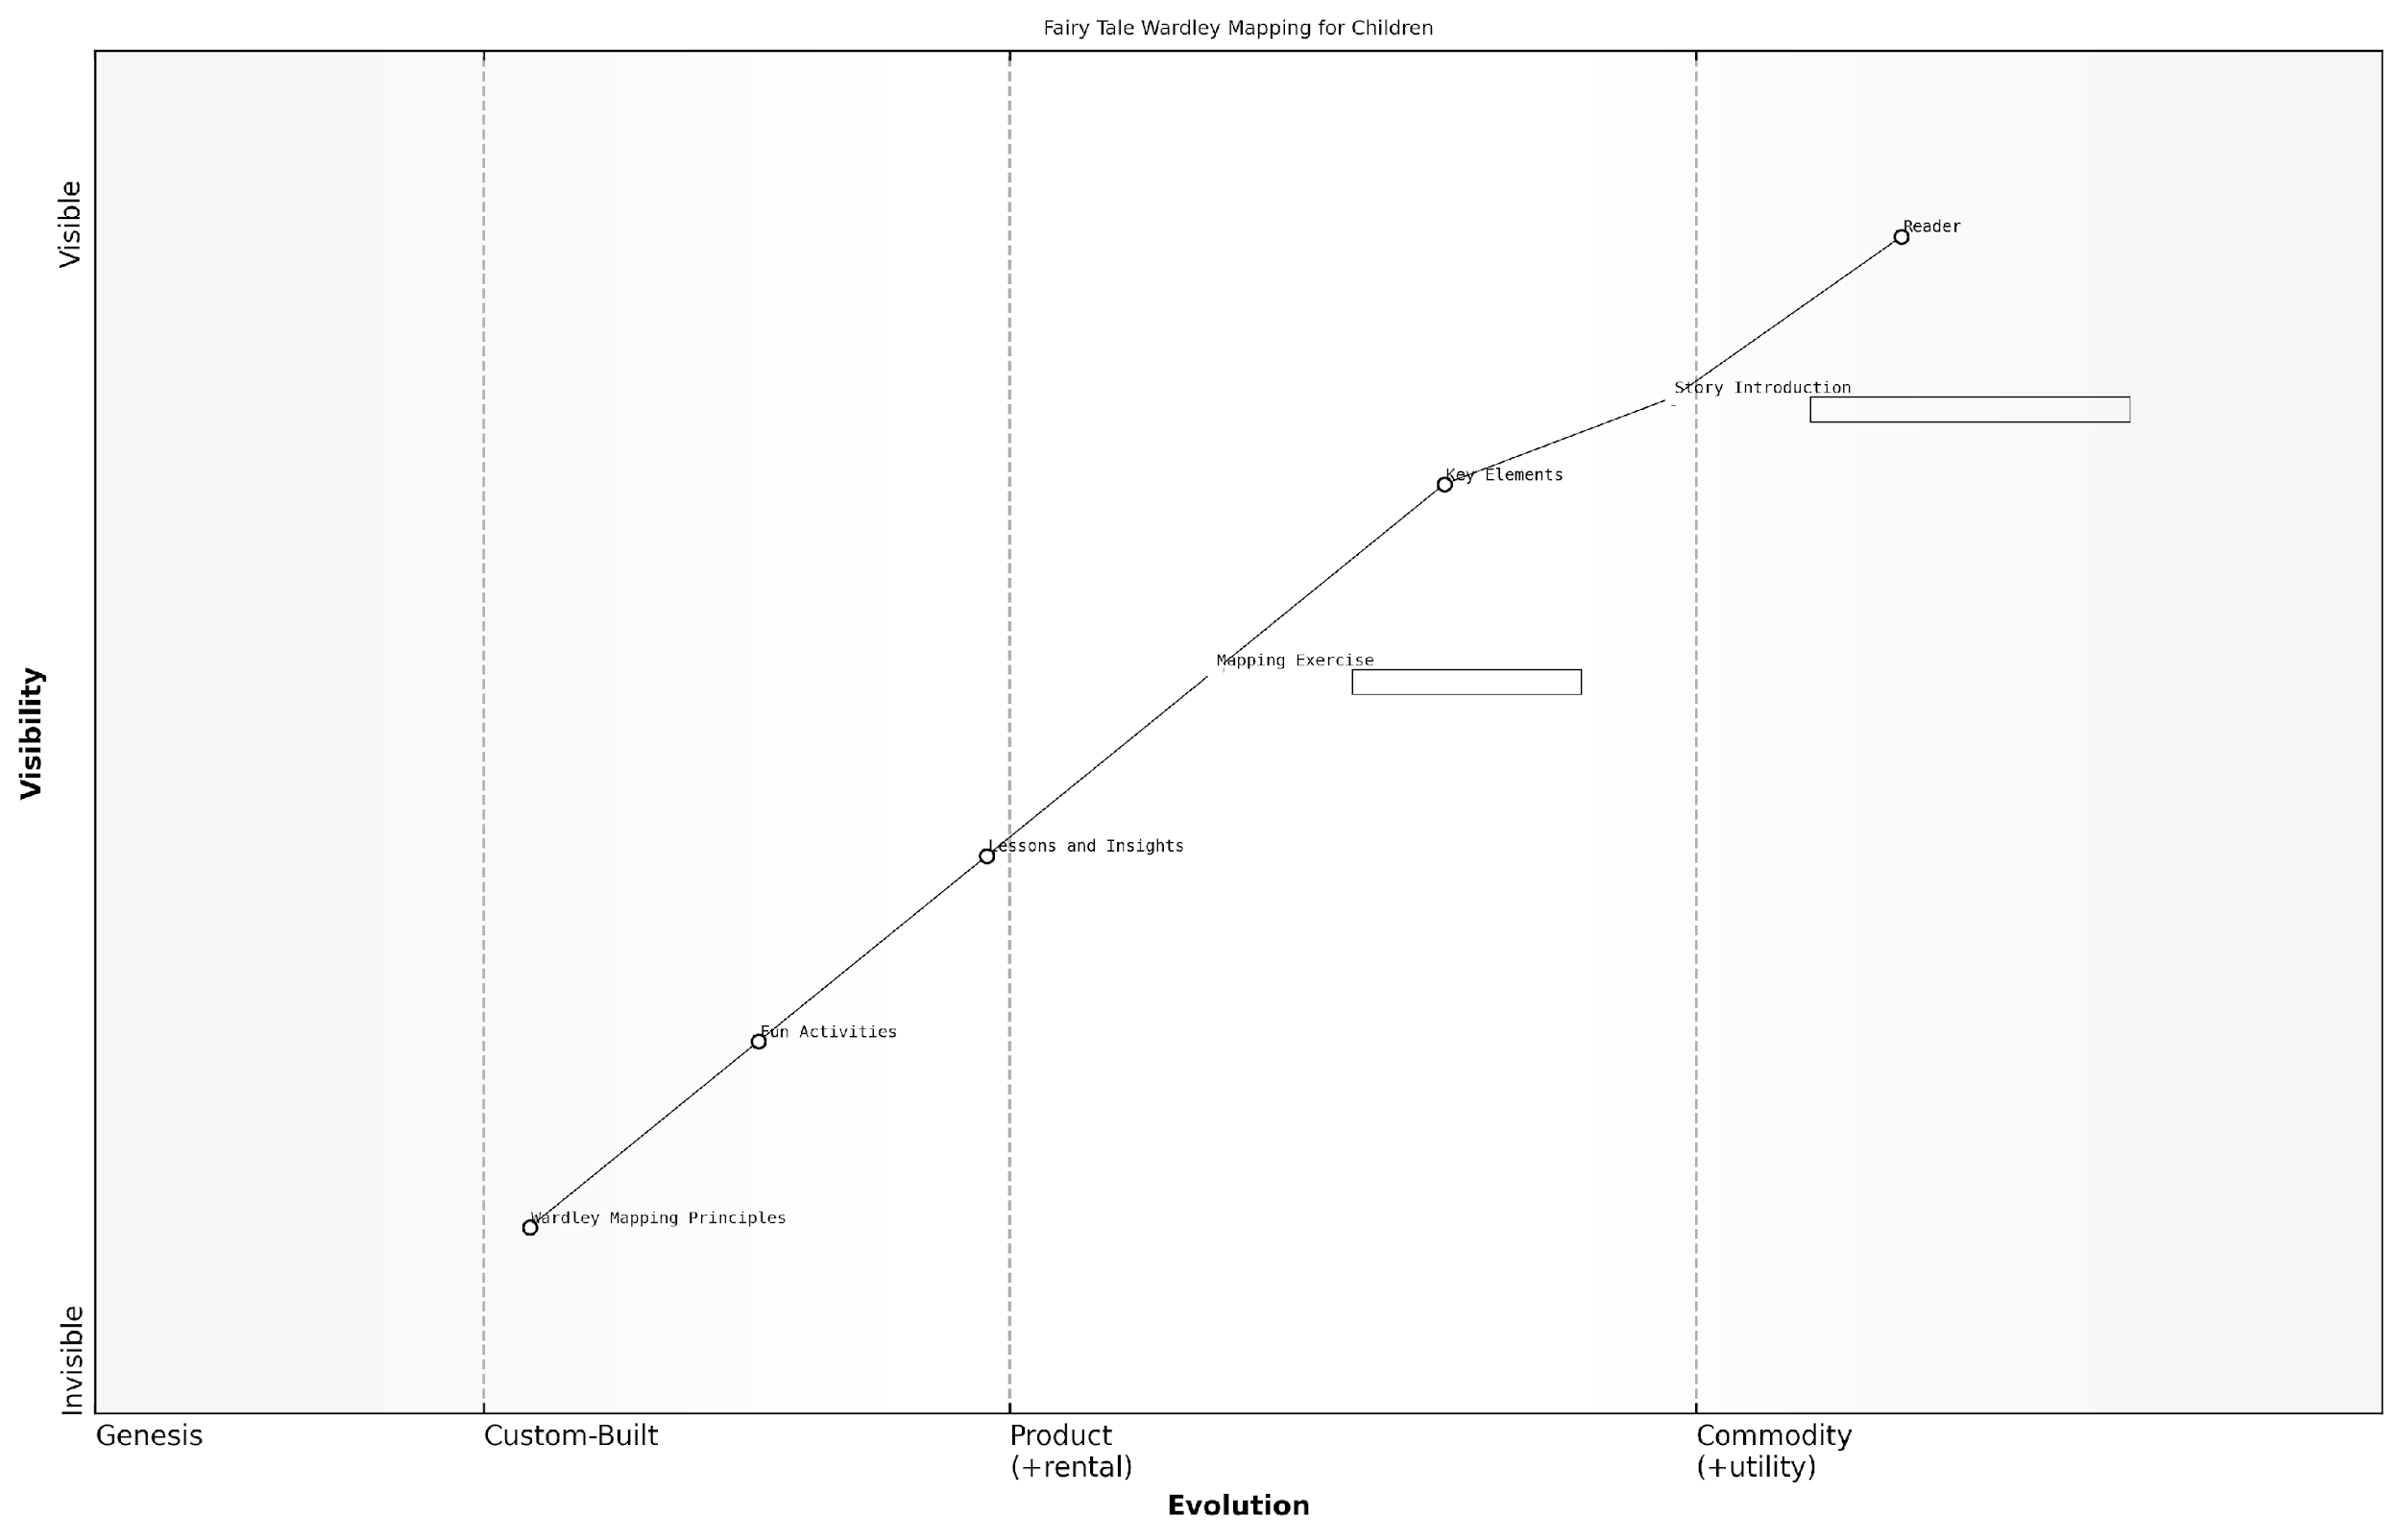

*Draft Wardley Map: [Insert Wardley Map: The structure of each chapter]*

[Edit this draft Wardley Map](https://create.wardleymaps.ai/#clone:b65479a7053024286d)

Wardley Map Assessment

This Wardley Map represents an innovative approach to introducing strategic thinking and Wardley Mapping concepts to children through familiar fairy tales. The structure balances engagement and education effectively, with a clear progression from accessible story elements to more complex mapping principles. The unique positioning in the intersection of children’s literature and strategic education offers significant opportunities for differentiation and value creation. Key challenges lie in maintaining the right balance of entertainment and education, and in effectively simplifying complex concepts without losing their essence. The future success of this approach will depend on continuous refinement based on user feedback, strategic partnerships within both educational and Wardley Mapping communities, and the ability to evolve with technological advancements in interactive learning. Overall, this map indicates a promising and potentially disruptive approach to early strategic education, with room for expansion and evolution in multiple directions.

[View full Wardley Map report](http://markdown_wardley_map_reports/wardley_map_report_03_The_structure_of_each_chapter.md)

### How to use this book with children

This book is designed to introduce children to the concept of Wardley Mapping through familiar fairy tales. Here’s how you can make the most of it:

* Read each chapter together: Start by reading the fairy tale, then explore the mapping concepts.
* Discuss the story elements: Talk about the characters, their needs, and the components of their world.
* Create maps together: Use paper and pencils to draw simple maps based on the story.
* Apply lessons to real life: Encourage children to think about how they can use mapping in their own experiences.
* Make it interactive: Ask questions and encourage children to share their ideas throughout the process.

Remember, the goal is to make learning fun and engaging. Don’t worry about perfect maps - focus on encouraging creative thinking and problem-solving skills.

A renowned educator once said, ‘Children learn best when they’re having fun and can relate new concepts to familiar ideas.’

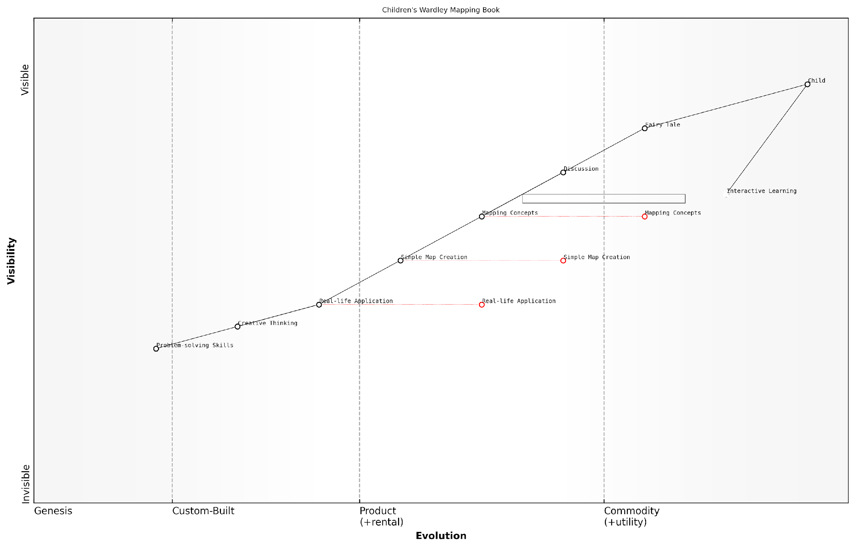

*Draft Wardley Map: [Insert Wardley Map: How to use this book with children]*

[Edit this draft Wardley Map](https://create.wardleymaps.ai/#clone:b1c008ace889ca4437)

Wardley Map Assessment

This map represents an innovative approach to introducing complex strategic concepts to children through familiar storytelling methods. The strategic positioning effectively bridges the gap between fairy tales and practical strategic thinking, with significant potential for growth and evolution in the educational technology space. Key focus areas should be enhancing interactivity, simplifying complex concepts, and developing robust real-life applications to ensure long-term engagement and value. The unique combination of storytelling and strategic education positions this product well in a niche market, with potential for broader impact on early business education.

[View full Wardley Map report](http://markdown_wardley_map_reports/wardley_map_report_04_How_to_use_this_book_with_children.md)

# Chapter 1: Hansel and Gretel’s Forest Adventure

## The Story of Hansel and Gretel

### A child-friendly retelling

Once upon a time, in a small cottage near a dark forest, there lived a poor woodcutter with his wife and two children, Hansel and Gretel. Times were hard, and food was scarce.

One night, Hansel overheard his parents talking about leaving the children in the forest because they couldn’t afford to feed them. Clever Hansel came up with a plan. He collected small white pebbles and left a trail behind them as their parents led them into the forest the next day.

Thanks to the pebbles, Hansel and Gretel found their way back home. But soon after, they were taken into the forest again. This time, Hansel could only use breadcrumbs, which were eaten by birds.

Lost and hungry, the children stumbled upon a magical house made of sweets and cakes. As they began to eat, an old witch appeared and trapped them. She planned to fatten up Hansel and eat him!

Gretel, using her quick thinking, tricked the witch and pushed her into her own oven. The children found the witch’s treasure, took it, and used it to find their way back home, where they lived happily ever after with their father.

A wise storyteller once said, ‘In every challenge, there’s an opportunity for bravery and cleverness to shine through.’

### Key elements of the story

Once upon a time, there lived a poor woodcutter with his wife and two children, Hansel and Gretel. During a terrible famine, the woodcutter’s wife convinced him to abandon the children in the forest to save food for themselves.

Hansel overheard the plan and collected pebbles to mark their path. The next day, they were led into the forest, but Hansel used the pebbles to find their way back home.

The parents tried again, but this time Hansel used breadcrumbs instead of pebbles. Unfortunately, birds ate the breadcrumbs, and the children became lost in the forest.

Hungry and tired, they stumbled upon a house made of sweets and cakes. As they began to eat, a wicked witch who lived there captured them, intending to fatten up Hansel and eat him.

Gretel cleverly tricked the witch into her own oven, saving her brother. The children found treasure in the witch’s house and returned home to their remorseful father, who had been searching for them.

* Poverty and famine leading to difficult decisions
* Clever problem-solving by the children
* The dangers of the unknown forest
* Temptation and deception (the sweet house)
* Bravery and quick thinking to overcome evil
* The importance of family and forgiveness

## Mapping Hansel and Gretel’s Journey

### Identifying user needs

In our journey to map Hansel and Gretel’s adventure, we first need to identify their user needs. User needs are the basic things that our characters want or require to solve their problems or achieve their goals.

Let’s think about what Hansel and Gretel really need in their story:

* Food: They are hungry and need something to eat
* Safety: They need protection from danger in the forest
* Shelter: They need a place to stay and keep warm
* A way home: They need to find their way back to their family

These are the basic needs that drive Hansel and Gretel’s actions throughout their adventure. By identifying these needs, we can start to understand why they make certain choices and how different elements in the story help or hinder them.

A wise business leader once said, ‘Understanding what people truly need is the first step in creating something valuable.’

Just like in Hansel and Gretel’s story, identifying user needs is crucial in the real world too. It helps us create better products, services, and solutions that truly help people.

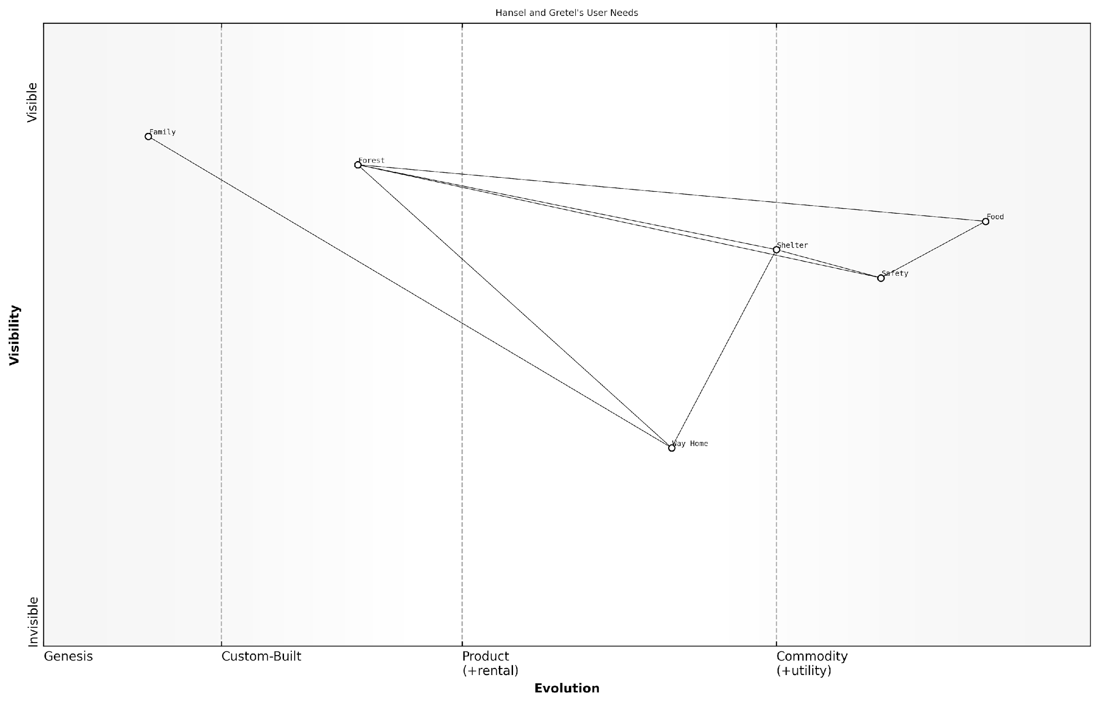

*Draft Wardley Map: [Insert Wardley Map: Identifying user needs]*

[Edit this draft Wardley Map](https://create.wardleymaps.ai/#clone:684277c01f34ebc25d)

Wardley Map Assessment

This Wardley Map illustrates a survival-focused strategy with a clear end goal. The key to success lies in balancing immediate survival needs with progress towards finding a way home. The main strategic challenge is evolving the ‘Way Home’ component while maintaining proficiency in survival skills. Future success depends on developing a deep understanding of the forest ecosystem and continuously improving navigation capabilities.

[View full Wardley Map report](http://markdown_wardley_map_reports/wardley_map_report_07_Identifying_user_needs.md)

### Mapping the components

Now that we’ve identified Hansel and Gretel’s main need - to find their way home - let’s map out the components of their journey. We’ll break down their adventure into different parts and see how they relate to each other.

* Breadcrumbs: Hansel’s clever idea to mark their path
* Forest: The setting of their adventure
* Gingerbread house: An unexpected discovery
* Witch: The main obstacle they face
* Cage: Where Hansel is trapped
* Oven: The tool Gretel uses to defeat the witch
* Treasures: What they find in the witch’s house
* Duck: Helps them cross the river on their way home

Let’s arrange these components on our map. We’ll put the most visible things to Hansel and Gretel at the top, and the less visible things at the bottom. We’ll also think about which components depend on others.

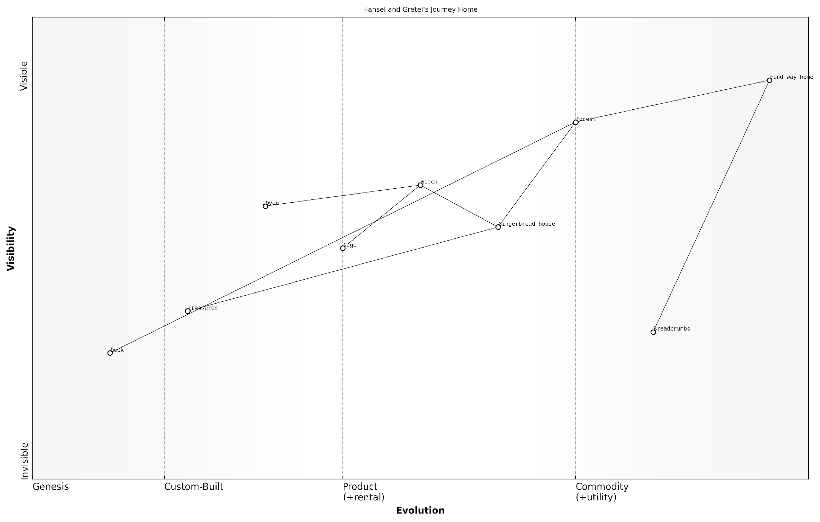

*Draft Wardley Map: [Insert Wardley Map: Mapping the components]*

[Edit this draft Wardley Map](https://create.wardleymaps.ai/#clone:3c65a3c55b8bb1b4c6)

Wardley Map Assessment

This Wardley Map of Hansel and Gretel’s journey home reveals a complex, multi-stage challenge with various obstacles, tools, and opportunities. The strategic position is one of vulnerability but with potential for growth and success. Key opportunities lie in developing more reliable navigation methods, enhancing problem-solving skills, and remaining open to unexpected sources of aid. The main risks come from deception (Gingerbread house) and direct threats (Witch, Cage), emphasising the need for caution and adaptability. Future strategies should focus on building resilience, improving threat detection, and developing a more comprehensive understanding of the environment (Forest). The unexpected elements (like the Duck) suggest that flexibility and openness to unconventional solutions will be crucial for success in similar future journeys.

[View full Wardley Map report](http://markdown_wardley_map_reports/wardley_map_report_08_Mapping_the_components.md)

This map helps us see how different parts of the story connect. For example, the breadcrumbs depend on the forest, and the gingerbread house leads to encountering the witch. By mapping it out this way, we can better understand the story and think about how Hansel and Gretel might plan their actions.

A wise strategist once said, ‘Understanding how things connect helps us make better decisions.’

### Understanding evolution

As we map Hansel and Gretel’s journey through the forest, we can see how different elements of their adventure evolve over time. This concept of evolution is crucial in Wardley Mapping, as it helps us understand how things change and become more or less important.

* Breadcrumbs: From novel idea to unreliable method
* Pebbles: A more reliable and evolved solution
* The witch’s house: An unexpected new component
* Hansel and Gretel’s problem-solving skills: Evolving through experience

Let’s look at how the breadcrumbs evolve. At first, they seem like a clever new idea (genesis stage). But as birds eat them, the breadcrumbs become unreliable and move towards the custom-built stage. This shows how some ideas may not work as well as we hope.

The pebbles, on the other hand, represent a more evolved solution. They’re more reliable and could be seen as a product-stage component in our map. This shows how we can learn from mistakes and find better solutions.

A wise storyteller once said, ‘In every journey, we learn and grow. Our tools and methods evolve as we face new challenges.’

By understanding how things evolve in Hansel and Gretel’s story, we can learn to spot similar patterns in our own adventures and projects. This helps us make better plans and adapt when things don’t go as expected.

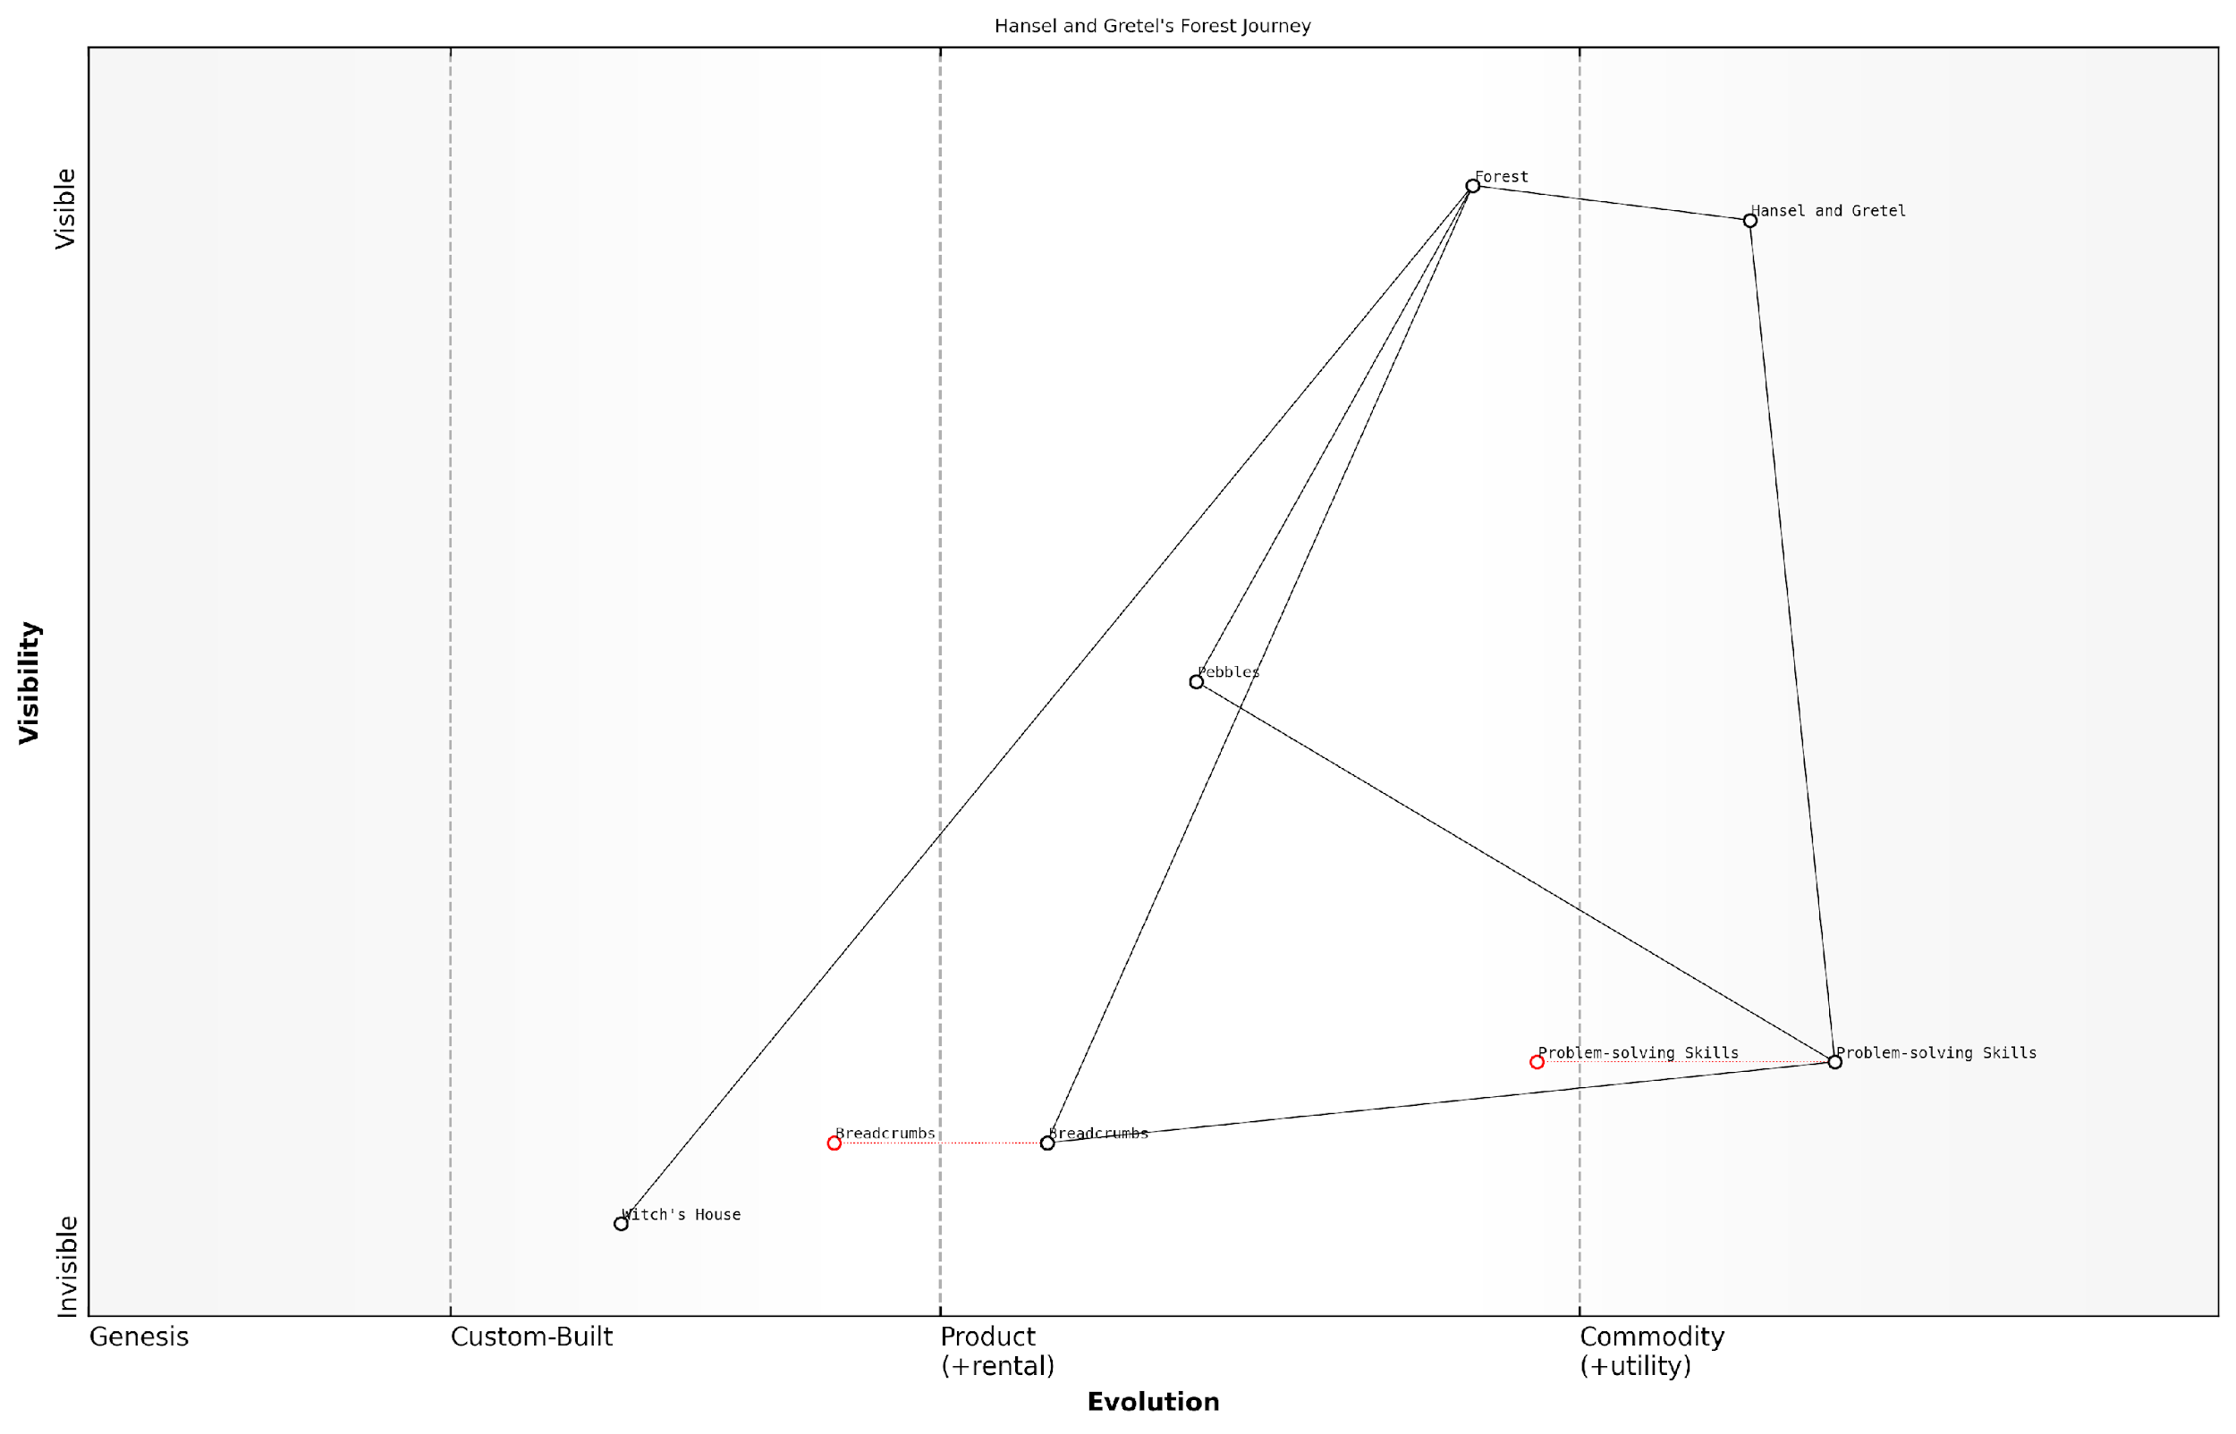

*Draft Wardley Map: [Insert Wardley Map: Understanding evolution]*

[Edit this draft Wardley Map](https://create.wardleymaps.ai/#clone:0a022da420ac6441c8)

Wardley Map Assessment

The map represents a survival scenario where adaptability and problem-solving are key. The strategic focus should be on rapidly evolving Problem-solving Skills while developing a deeper understanding of the Forest ecosystem. Innovation in navigation methods and risk mitigation strategies for threats like the Witch’s House are crucial for long-term success. The evolving nature of key components suggests a dynamic environment requiring continuous adaptation and skill development.

[View full Wardley Map report](http://markdown_wardley_map_reports/wardley_map_report_09_Understanding_evolution.md)

## Lessons from the Map

### The importance of planning

Hansel and Gretel’s journey through the forest teaches us a valuable lesson about the importance of planning. By mapping out their adventure, we can see how proper planning could have changed their story.

* Preparation prevents problems: If Hansel and Gretel had planned their journey, they might have avoided getting lost.
* Resources matter: Planning helps identify what resources you need, like Hansel’s clever use of breadcrumbs.
* Know your environment: Understanding the forest (or any situation) helps you make better decisions.
* Have a backup plan: Things don’t always go as expected, so it’s good to have alternatives ready.

A wise fairy tale character once said, ‘Look before you leap into the forest of life.’

By creating a map of Hansel and Gretel’s journey, we can see how planning ahead could have helped them avoid danger and find their way home more easily. This teaches us that in our own lives, taking time to plan and understand our situation can lead to better outcomes and fewer surprises along the way.

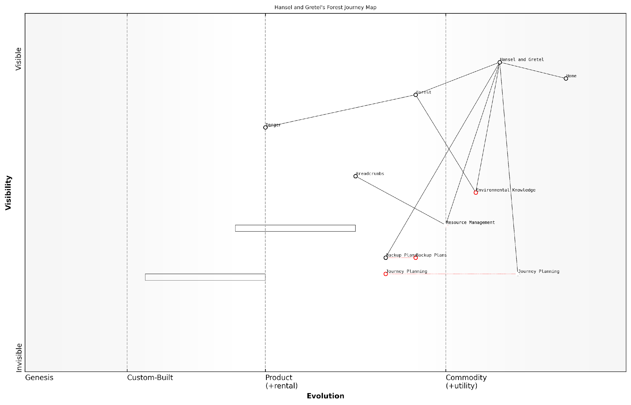

*Draft Wardley Map: [Insert Wardley Map: The importance of planning]*

[Edit this draft Wardley Map](https://create.wardleymaps.ai/#clone:e79e73de0bd2960ce3)

Wardley Map Assessment

The Hansel and Gretel Forest Journey map reveals a strategic landscape focused on safe forest navigation through planning, resource management, and knowledge acquisition. While innovative solutions like Breadcrumbs are present, the system faces challenges in predictability and reliability. The key opportunities lie in enhancing Journey Planning visibility, developing more robust Backup Plans, and advancing Environmental Knowledge systems. By focusing on these areas, particularly through leveraging emerging technologies and fostering ecosystem collaborations, Hansel and Gretel can significantly improve their forest navigation capabilities and overall safety. The evolving nature of critical components suggests a dynamic environment that requires continuous adaptation and innovation to maintain strategic advantage.

[View full Wardley Map report](http://markdown_wardley_map_reports/wardley_map_report_10_The_importance_of_planning.md)

### Adapting to change

Hansel and Gretel’s journey through the forest teaches us valuable lessons about adapting to change. As we map their adventure, we can see how they had to adjust their plans and strategies when faced with unexpected challenges.

* Be flexible: When their original plan of using breadcrumbs failed, Hansel and Gretel had to find new ways to navigate the forest.
* Use available resources: The children used pebbles and their own cleverness to overcome obstacles.
* Stay calm under pressure: Despite being in a scary situation, Hansel and Gretel kept their wits about them and worked together to find solutions.

By mapping Hansel and Gretel’s journey, we can see how different components of their adventure evolved. For example, their navigation methods changed from familiar paths to breadcrumbs to pebbles. This evolution shows us that sometimes we need to try different approaches when our first idea doesn’t work out.

A wise business leader once said, ‘The ability to adapt to change is the key to survival in any environment.’

Just like Hansel and Gretel, we can use mapping to help us understand our current situation and plan for changes that might come our way. By being aware of how things are evolving around us, we can make better decisions and find creative solutions to problems.

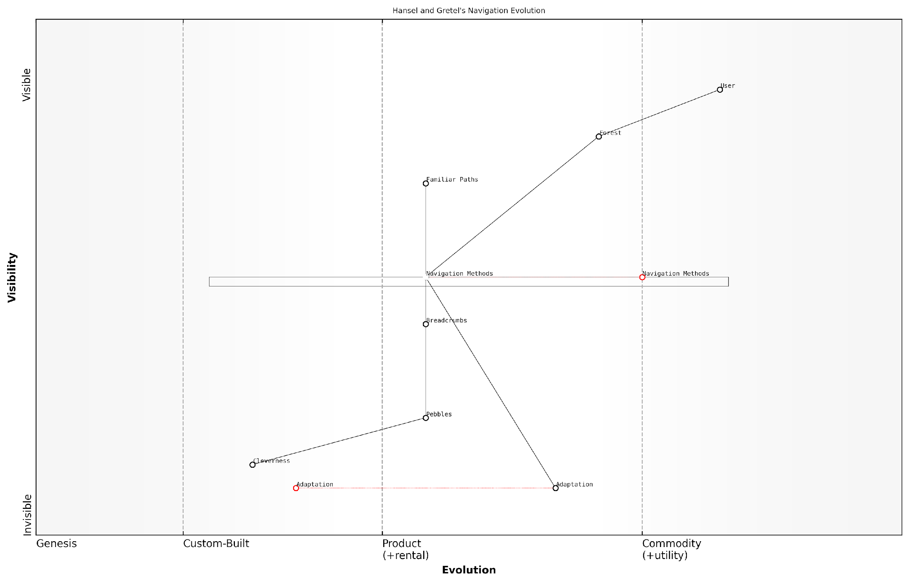

*Draft Wardley Map: [Insert Wardley Map: Adapting to change]*

[Edit this draft Wardley Map](https://create.wardleymaps.ai/#clone:3482f8104c211d5c6b)

Wardley Map Assessment

This Wardley Map illustrates a system in transition, moving from traditional navigation methods to more innovative and reliable approaches. The key strategic focus should be on enhancing Adaptation and Cleverness to drive continuous innovation in Navigation Methods. While Pebbles represents a significant improvement, there’s potential for even more advanced solutions. The system’s success hinges on balancing reliability with flexibility to handle the unpredictable nature of the Forest environment. By prioritizing the development of multiple, diverse navigation methods and fostering a strong capability for rapid adaptation, the system can ensure long-term resilience and effectiveness in meeting User needs.

[View full Wardley Map report](http://markdown_wardley_map_reports/wardley_map_report_11_Adapting_to_change.md)

### Finding your way home

In Hansel and Gretel’s adventure, finding their way home was a crucial part of their journey. By mapping their story, we can learn valuable lessons about navigation and problem-solving that apply to real-life situations.

* Use landmarks: Just as Hansel used breadcrumbs (and later, pebbles) to mark their path, we can identify key landmarks in our own journeys to help us find our way back.
* Adapt to changes: When the breadcrumbs didn’t work, Hansel and Gretel had to find new solutions. This teaches us to be flexible and creative when our original plans don’t work out.
* Work together: Hansel and Gretel supported each other throughout their adventure. Teamwork and communication are essential when trying to navigate difficult situations.
* Trust your instincts: The children knew something was wrong and acted on their suspicions. Learning to trust our gut feelings can help us avoid or overcome challenges.
* Learn from experience: Each time Hansel and Gretel ventured into the forest, they learned something new. We can apply past experiences to help us navigate future challenges.

By applying these lessons from Hansel and Gretel’s map to our own lives, we can become better at finding our way through unfamiliar situations and overcoming obstacles we encounter along the way.

As a wise storyteller once said, ‘Every journey, no matter how difficult, can teach us valuable lessons about finding our way home – both literally and figuratively.’

# Chapter 2: The Three Little Pigs’ Construction Project

## The Tale of the Three Little Pigs

### A simplified version for children

Once upon a time, there were three little pigs who decided to build their own houses. Their mother told them to be careful and build strong houses to keep them safe from the big bad wolf.

The first little pig was in a hurry and built his house out of straw. It was quick and easy, but not very strong.

The second little pig took a bit more time and built his house out of sticks. It was stronger than the straw house, but still not very sturdy.

The third little pig was very wise and spent a long time building his house out of bricks. It took a lot of work, but his house was very strong.

One day, the big bad wolf came along. He huffed and puffed and blew down the straw house. Then he huffed and puffed and blew down the stick house. But when he tried to blow down the brick house, he couldn’t do it!

In the end, all three little pigs were safe in the brick house, and they learned an important lesson about the value of hard work and planning.

‘The strongest houses are built with patience and care,’ a wise builder once said.

### Important story elements

Once upon a time, there were three little pigs who set out to build their own houses. Each pig had a different idea about how to construct their home.

* The first pig built a house of straw, thinking it would be quick and easy.
* The second pig chose sticks, believing they would be stronger than straw.
* The third pig decided to use bricks, understanding that it would take more time but provide better protection.

Along came a big bad wolf, who was hungry and wanted to eat the pigs. He visited each house, trying to blow them down to get to the pigs inside.

* The straw house was easily blown down, and the first pig had to run to safety.
* The stick house lasted a bit longer but was eventually destroyed, forcing the second pig to flee.
* The brick house stood strong against the wolf’s huffing and puffing, keeping the third pig safe.

In the end, all three pigs found safety in the brick house, learning an important lesson about the value of careful planning and using strong materials.

A wise builder once said, ‘The time and effort you invest in your foundation determines how long your structure will stand.’

## Mapping the Pigs’ Building Strategies

### Identifying the pigs’ needs

Now that we’ve identified the pigs’ needs, let’s map out their building strategies using a simple Wardley Map. We’ll start by placing the pigs’ main need - a safe home - at the top of our map.

* Draw a vertical line on the left side of your paper. This represents how visible things are to the pigs.
* Draw a horizontal line at the bottom. This shows how evolved or common things are.
* Put ‘Safe Home’ at the top of the map - it’s the most visible need.

Next, we’ll add the different building materials the pigs used:

* Straw: Place it low on the visibility axis and to the right on the evolution axis. It’s easy to find and use.
* Sticks: Put this in the middle for visibility and evolution. It’s a bit stronger and takes more effort to build with.
* Bricks: Position this higher on the visibility axis and to the left on the evolution axis. It’s the most complex and least common building material for the pigs.

Now, let’s add some other important components:

* Building skills: Place this in the middle, as it’s somewhat visible and evolves as the pigs learn.
* Wolf-proofing: Put this high on visibility but low on evolution, as it’s very important but not well understood at first.
* Time to build: Position this low on visibility but high on evolution, as it’s not immediately obvious but becomes more important as they learn.

A wise business leader once said, ‘Understanding how different parts of a project relate to each other is key to success.’

By mapping out these components, we can see how the pigs’ building strategies evolved from quick and simple to more complex and secure. This helps us understand their decision-making process and the trade-offs they faced.

### Mapping building materials and methods

Now that we’ve identified the pigs’ needs, let’s map out the building materials and methods they used. This will help us understand how each pig approached their construction project.

* Straw House: The first pig’s choice
* Stick House: The second pig’s approach
* Brick House: The third pig’s strategy

We’ll place these building materials on our map based on how evolved they are. Straw is the least evolved, as it’s easy to find and requires little processing. Sticks are a bit more evolved, needing some collection and preparation. Bricks are the most evolved, requiring manufacturing and specialised skills to use effectively.

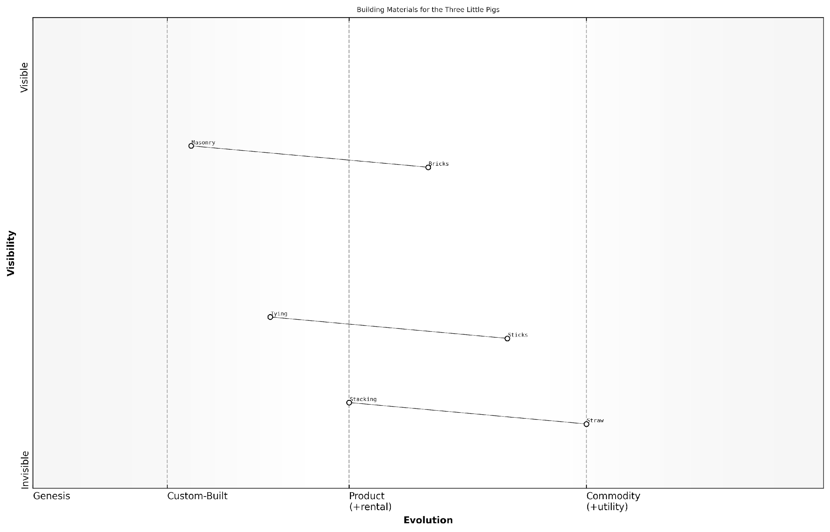

*Draft Wardley Map: [Insert Wardley Map: Mapping building materials and methods]*

[Edit this draft Wardley Map](https://create.wardleymaps.ai/#clone:8e17f8b41d736b1d1b)

Wardley Map Assessment

This Wardley Map illustrates a simplified yet insightful representation of the construction industry through the lens of the Three Little Pigs story. It highlights the progression from basic to advanced materials and methods, emphasising the need for alignment between material evolution and construction technique advancement. The strategic focus should be on optimising high-value components like brick production and masonry skills, while also investing in innovation to bridge the gap between material availability and construction method efficiency. There’s significant potential for industry advancement through standardisation, skill development, and the exploration of new materials and techniques that combine durability with ease of use.

[View full Wardley Map report](http://markdown_wardley_map_reports/wardley_map_report_16_Mapping_building_materials_and_methods.md)

Next, let’s consider the building methods used by each pig. We can add these to our map to show how they relate to the materials:

* Stacking: Used for the straw house
* Tying: Used for the stick house
* Masonry: Used for the brick house

We’ll position these methods on our map, showing how they relate to the materials and how evolved they are as construction techniques.



*Draft Wardley Map: [Insert Wardley Map: Mapping building materials and methods]*

[Edit this draft Wardley Map](https://create.wardleymaps.ai/#clone:8e17f8b41d736b1d1b)

Wardley Map Assessment

This Wardley Map illustrates a simplified yet insightful representation of the construction industry through the lens of the Three Little Pigs story. It highlights the progression from basic to advanced materials and methods, emphasising the need for alignment between material evolution and construction technique advancement. The strategic focus should be on optimising high-value components like brick production and masonry skills, while also investing in innovation to bridge the gap between material availability and construction method efficiency. There’s significant potential for industry advancement through standardisation, skill development, and the exploration of new materials and techniques that combine durability with ease of use.

[View full Wardley Map report](http://markdown_wardley_map_reports/wardley_map_report_16_Mapping_building_materials_and_methods.md)

A wise builder once said, ‘The strength of a house lies not just in its materials, but in how they are put together.’

### Exploring evolution in construction

In our map of the Three Little Pigs’ construction project, we can see how building materials and techniques evolve over time. This evolution reflects the pigs’ learning process and the increasing sophistication of their approach to home building.

* Straw house: The most basic and least evolved building method
* Stick house: A step up in durability and complexity
* Brick house: The most evolved and secure construction

As we map out these different building approaches, we can see how each pig’s choice represents a different stage in the evolution of construction. The straw house is at the ‘genesis’ stage - it’s quick and easy to build, but not very sturdy. The stick house is in the ‘custom-built’ phase, showing some improvement but still not fully developed. The brick house represents a more ‘product’ stage, with standardised materials and proven techniques.

A wise builder once said, ‘The true test of a house is not how it looks, but how it stands against the wind.’

This evolution in construction methods teaches us an important lesson about how things improve over time through learning and experience. It also shows us that sometimes, investing more time and effort in the beginning can lead to better results in the long run.

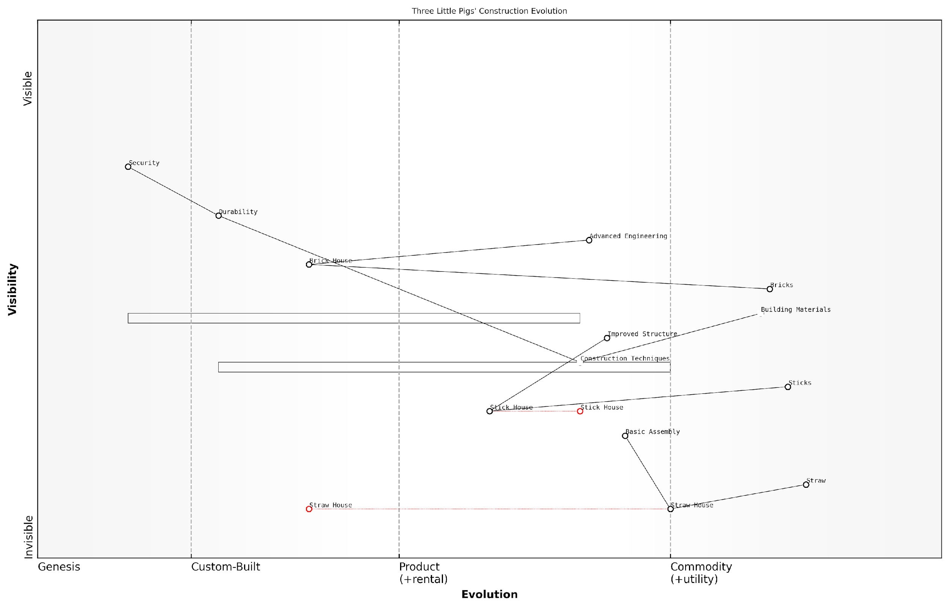

*Draft Wardley Map: [Insert Wardley Map: Exploring evolution in construction]*

[Edit this draft Wardley Map](https://create.wardleymaps.ai/#clone:8084451fede520186f)

Wardley Map Assessment

This Wardley Map effectively illustrates the evolution of construction practices through a familiar narrative. It highlights the strategic importance of advancing building materials and techniques to achieve better security and durability. The map suggests that the future of construction lies in further evolving materials and techniques, potentially towards smart, sustainable, and automated solutions. To stay competitive, organisations in this space should focus on innovation in materials, standardisation of advanced techniques, and the integration of emerging technologies. The key challenge will be balancing the need for evolution with maintaining affordability and accessibility of construction services.

[View full Wardley Map report](http://markdown_wardley_map_reports/wardley_map_report_17_Exploring_evolution_in_construction.md)

## Insights from the Map

### The value of planning ahead

The Three Little Pigs’ story teaches us an important lesson about planning ahead. By mapping out their construction project, we can see how each pig’s approach led to different outcomes.

* The first pig’s straw house: Quick to build but easily destroyed
* The second pig’s stick house: Stronger, but still not sturdy enough
* The third pig’s brick house: Takes longer to build, but provides the best protection

Our map shows that the third pig’s strategy of planning ahead and investing time in a stronger house paid off in the long run. This teaches children that sometimes it’s worth taking more time to do things right, especially when it comes to important projects or decisions.

A wise business leader once said, ‘Failing to plan is planning to fail.’

By using a Wardley Map to visualise the pigs’ construction choices, we can help children understand how planning ahead and considering long-term consequences can lead to better outcomes in their own lives.

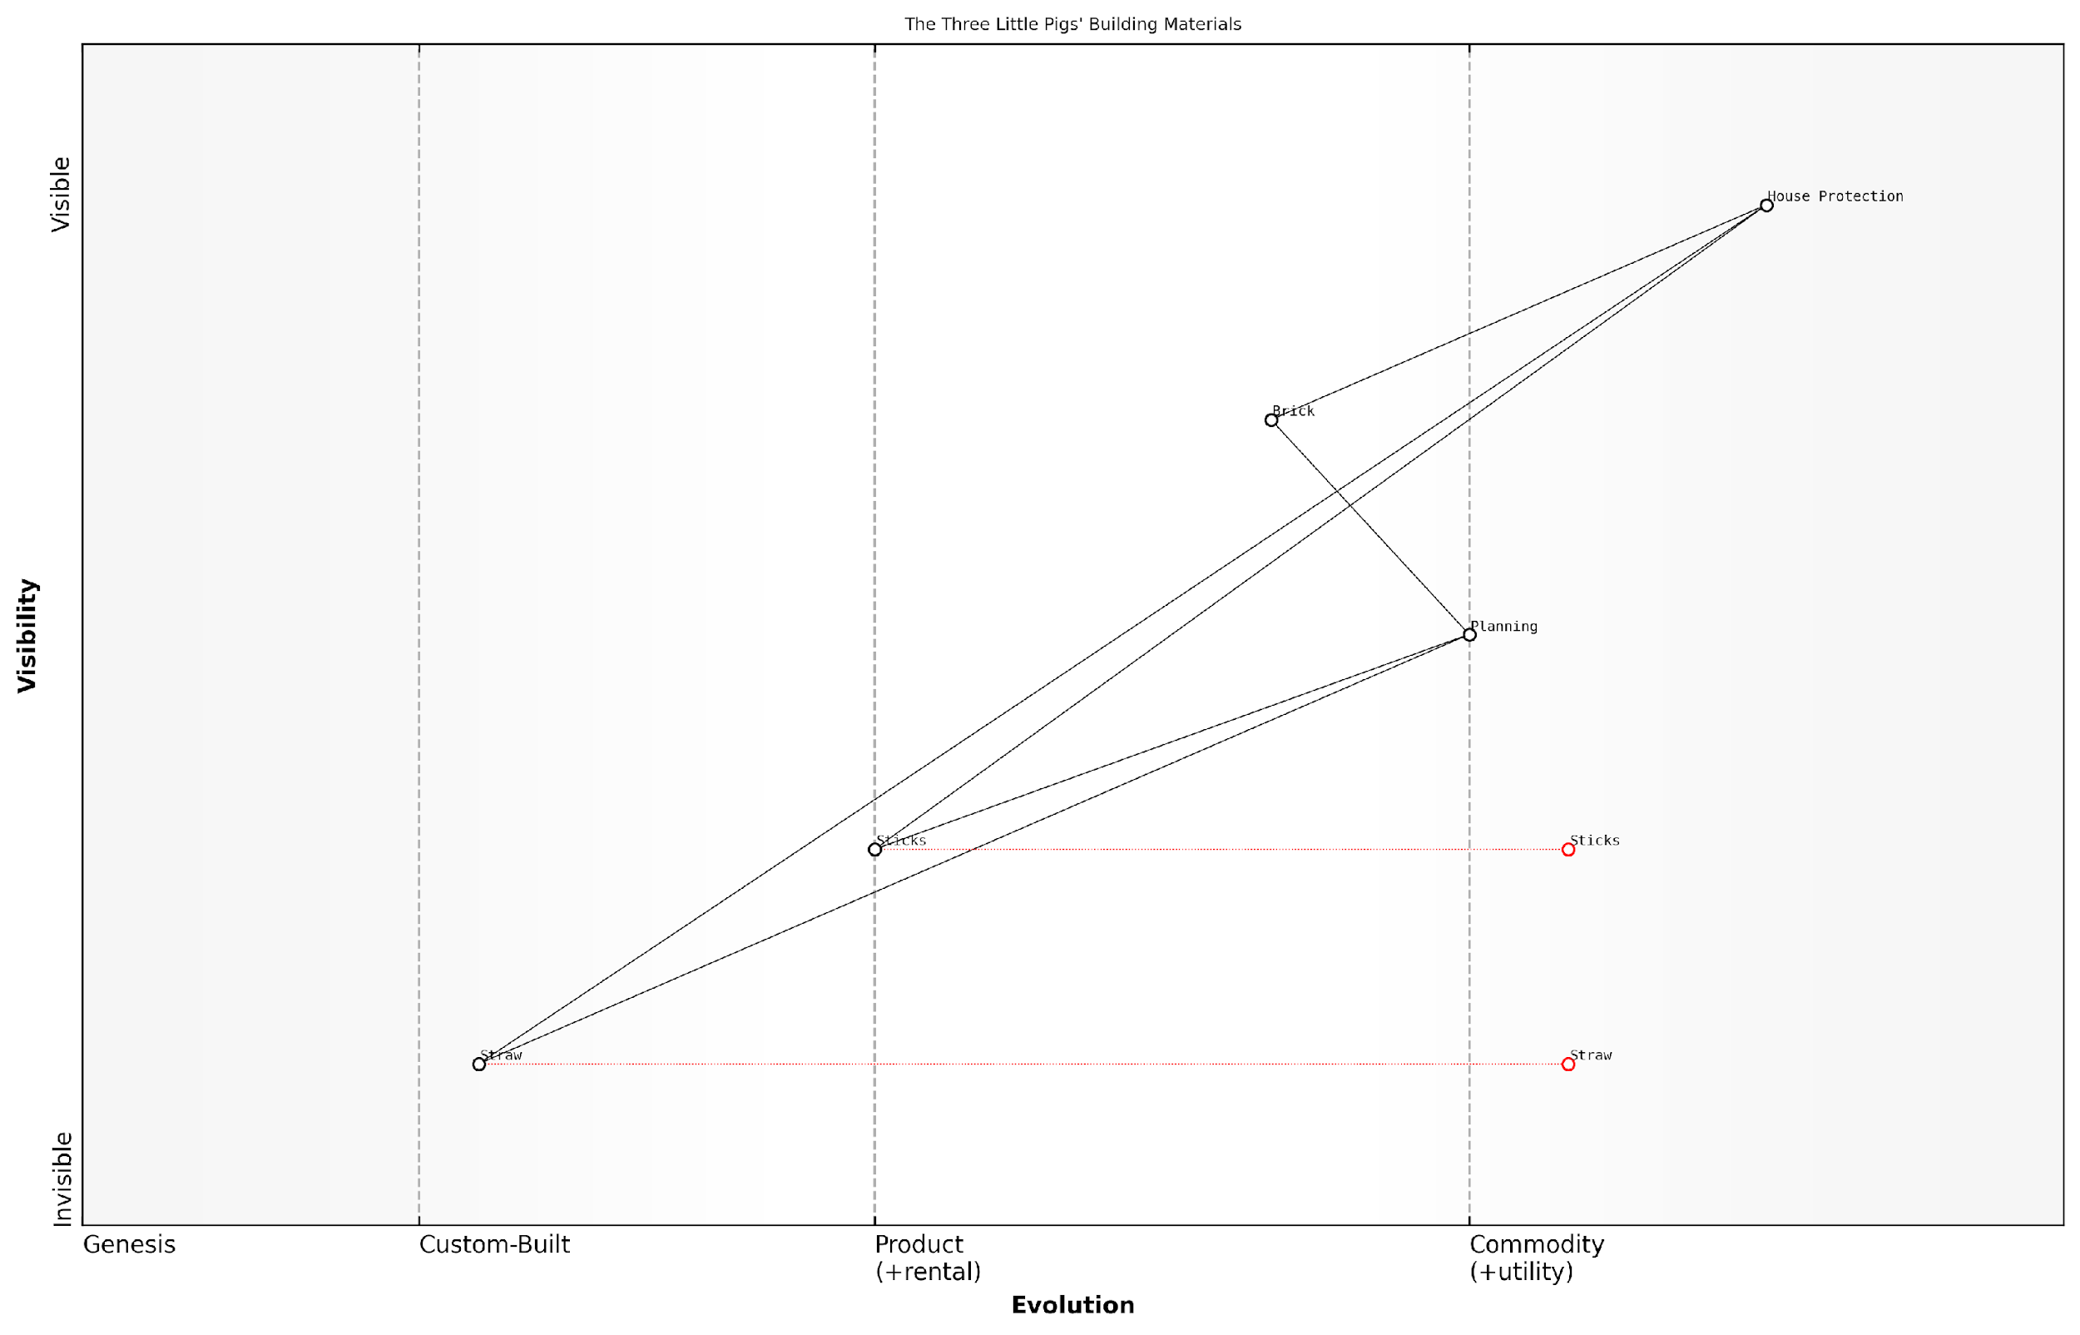

*Draft Wardley Map: [Insert Wardley Map: The value of planning ahead]*

[Edit this draft Wardley Map](https://create.wardleymaps.ai/#clone:77542e53ea4d85300d)

Wardley Map Assessment

This map illustrates the critical role of planning in maximising the value of construction materials. While there’s a clear hierarchy in material effectiveness, the strategic focus should be on enhancing planning capabilities and fostering innovation in material development. The ecosystem has significant potential for greater integration and collaboration, which could lead to more efficient and effective construction processes. Future strategies should balance the optimization of current practices with investment in emerging technologies and materials.

[View full Wardley Map report](http://markdown_wardley_map_reports/wardley_map_report_18_The_value_of_planning_ahead.md)

### Balancing speed and quality

The Three Little Pigs’ map teaches us an important lesson about balancing speed and quality in our projects. Each pig’s approach represents a different point on this balance:

* The first pig built quickly with straw, but the house wasn’t strong.
* The second pig used sticks, which was a bit slower but still not strong enough.
* The third pig took the most time to build with bricks, creating the strongest house.

From our map, we can see that the stronger materials are further along the evolution axis, showing they’re more developed and reliable. However, they also take more time and effort to use.

A wise business leader once said, ‘Good, fast, cheap: pick two.’ This applies to our pigs’ situation perfectly.

The map helps us understand that sometimes we need to move quickly, like when the wolf is coming. Other times, we can take more time to build something that will last. The key is knowing when to choose speed and when to prioritise quality based on our needs and the situation.

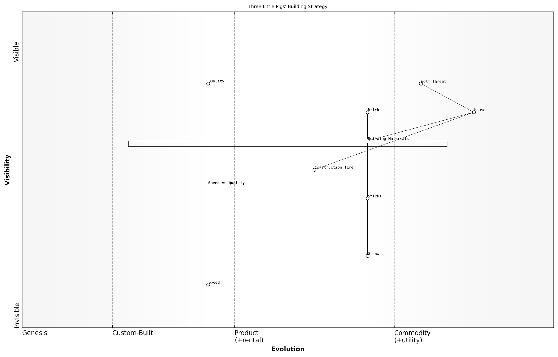

*Draft Wardley Map: [Insert Wardley Map: Balancing speed and quality]*

[Edit this draft Wardley Map](https://create.wardleymaps.ai/#clone:00b12d11a1d2e3dba5)

Wardley Map Assessment

This map effectively illustrates the strategic challenges in balancing speed, quality, and security in construction. It highlights the importance of long-term thinking and quality investment in the face of significant threats. The key strategic imperative is to move towards a balanced approach that maintains security while optimising efficiency, potentially through innovation in materials and construction techniques. The ecosystem would benefit from increased collaboration and knowledge sharing among all players to enhance overall resilience and adaptability.

[View full Wardley Map report](http://markdown_wardley_map_reports/wardley_map_report_19_Balancing_speed_and_quality.md)

### Learning from mistakes

The Three Little Pigs’ story teaches us valuable lessons about learning from mistakes, which we can see clearly on our Wardley Map. Let’s explore how the pigs’ experiences can help us understand the importance of learning and improving.

* Recognising weak strategies: The first two pigs’ houses failed because they didn’t consider the wolf’s strength. On our map, we can see how their building materials were not evolved enough to meet their safety needs.
* Adapting and improving: The third pig learned from his brothers’ mistakes and chose a more evolved building material (bricks). This shows how we can use past experiences to make better choices.
* The value of preparation: By mapping out their options, the pigs could have seen that investing more time and effort in stronger materials would pay off in the long run.

By using a Wardley Map to analyse the pigs’ choices, we can see how important it is to learn from our mistakes and those of others. This helps us make better decisions and create stronger strategies for the future.

A wise person once said, ‘The only real mistake is the one from which we learn nothing.’

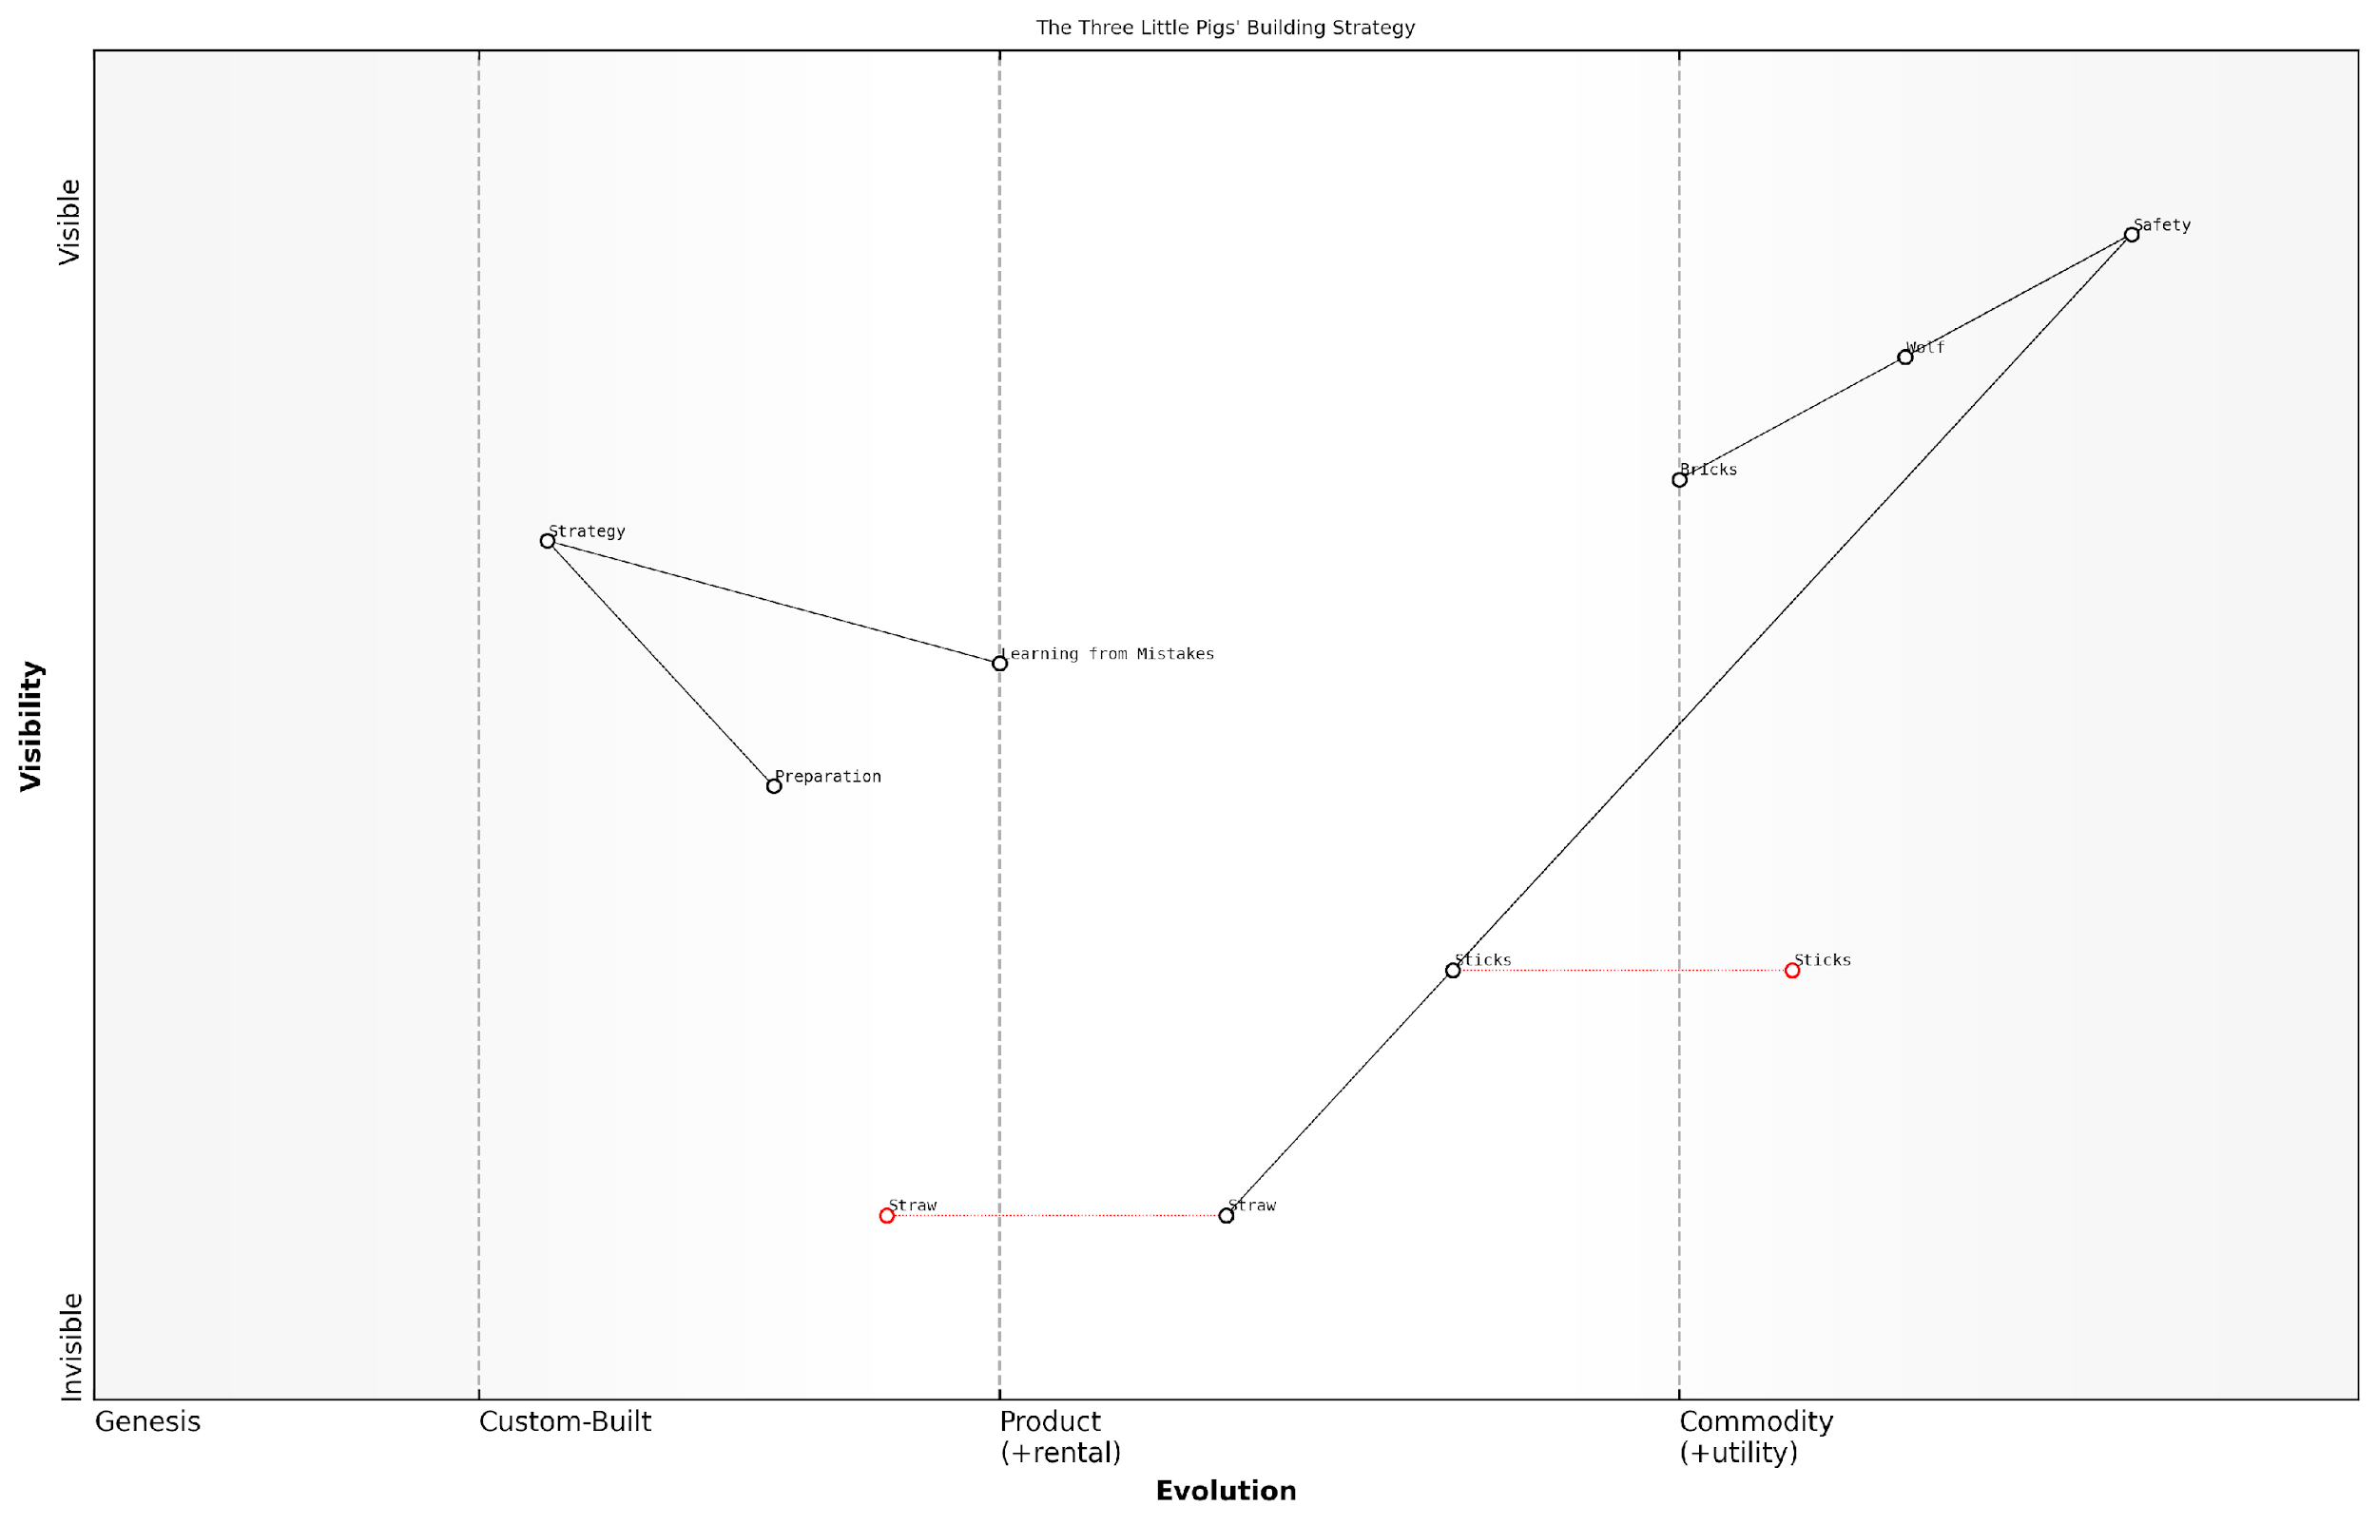

*Draft Wardley Map: [Insert Wardley Map: Learning from mistakes]*

[Edit this draft Wardley Map](https://create.wardleymaps.ai/#clone:904fb0cc403042167a)

Wardley Map Assessment

The map reveals a strategic landscape focused on survival through iterative learning and material improvement. While the pigs have made significant progress in their building strategies, there’s potential for more proactive and collaborative approaches. The key to long-term success lies in accelerating the learning process, exploring innovative building technologies, and developing more sophisticated predictive strategies. By shifting from a reactive to a proactive stance and leveraging collective knowledge, the pigs can create a more resilient and adaptive defence system against evolving threats.

[View full Wardley Map report](http://markdown_wardley_map_reports/wardley_map_report_20_Learning_from_mistakes.md)

# Chapter 3: Cinderella’s Magical Transformation

## The Story of Cinderella

### A child-appropriate retelling

Once upon a time, there was a kind and gentle girl named Cinderella. She lived with her stepmother and two stepsisters, who were very mean to her and made her do all the housework.

One day, an invitation arrived from the royal palace. The prince was hosting a grand ball, and all the young ladies in the kingdom were invited. Cinderella was excited, but her stepmother wouldn’t let her go.

As Cinderella sat crying in the garden, her Fairy Godmother appeared. With a wave of her magic wand, she transformed a pumpkin into a beautiful carriage, mice into horses, and Cinderella’s rags into a gorgeous gown and glass slippers.

At the ball, Cinderella danced with the prince, who fell in love with her. But at midnight, the magic wore off, and Cinderella had to run away, leaving behind one glass slipper.

The prince searched the kingdom for the girl whose foot fit the slipper. When he arrived at Cinderella’s house, the slipper fit her perfectly. Cinderella and the prince got married and lived happily ever after.

* Cinderella’s transformation from rags to riches
* The Fairy Godmother’s magic
* The glass slipper as a unique identifier
* The time limit on the magic (midnight)
* The prince’s search for Cinderella

### Key story components

Once upon a time, there was a kind and gentle girl named Cinderella. She lived with her mean stepmother and two jealous stepsisters, who made her do all the housework and treated her poorly.

One day, an invitation arrived from the royal palace. The prince was hosting a grand ball to find a bride, and all eligible young women in the kingdom were invited to attend.

* Cinderella’s difficult home life
* The royal ball invitation
* Cinderella’s fairy godmother
* Magical transformation
* The glass slipper
* The midnight deadline
* The prince’s search
* The happy ending

With the help of her fairy godmother’s magic, Cinderella is transformed and attends the ball. She must leave by midnight when the spell ends. At the ball, she captures the prince’s heart, but rushes away as the clock strikes twelve, leaving behind a glass slipper.

The prince searches the kingdom to find the girl whose foot fits the slipper. Despite her stepfamily’s attempts to hide her, Cinderella tries on the slipper, it fits perfectly, and she marries the prince, living happily ever after.

A wise storyteller once said, ‘Cinderella teaches us that with kindness, courage, and a little bit of magic, dreams can come true.’

## Mapping Cinderella’s Journey

### Identifying Cinderella’s needs

Now that we understand Cinderella’s story, let’s start mapping her journey! The first step in creating a Wardley Map is to identify the user’s needs. In this case, Cinderella is our user, and we need to figure out what she really wants and needs.

To identify Cinderella’s needs, we can look at her actions and desires throughout the story. Let’s think about what Cinderella hopes to achieve and what would make her happy.

* Attend the royal ball
* Escape her difficult home life
* Find love and happiness
* Be treated with kindness and respect

These needs will form the foundation of our map. We’ll place them at the top, as they are the most visible and important to Cinderella. From here, we can start to think about all the things that help Cinderella meet these needs, like her Fairy Godmother’s magic, her beautiful gown, and the pumpkin carriage.

A wise business leader once said, ‘Understanding your user’s needs is the first step to creating value and achieving success.’

By mapping out Cinderella’s needs and the components that support them, we can better understand her journey and the magical transformation that takes place. This will help us see how different elements of the story work together to help Cinderella achieve her dreams!

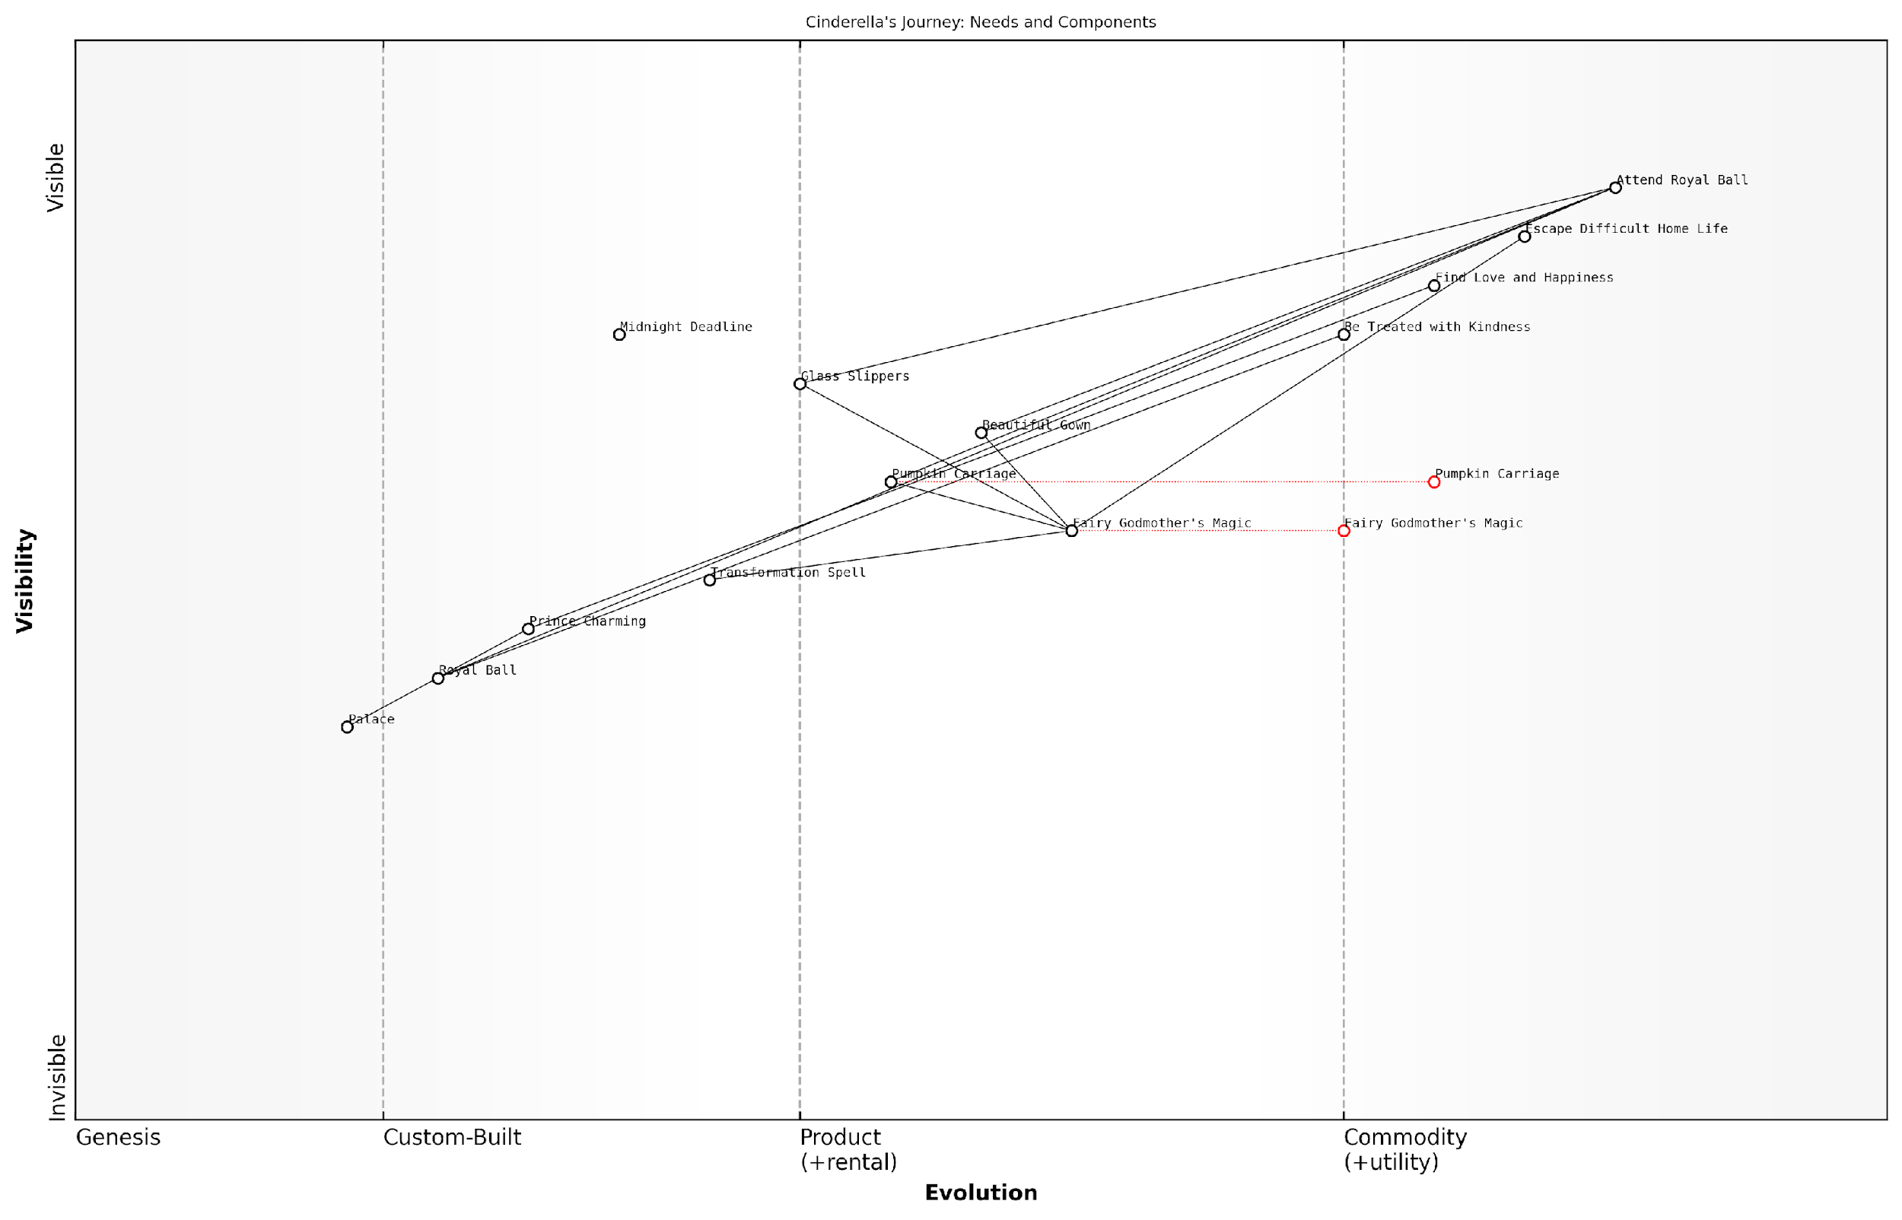

*Draft Wardley Map: [Insert Wardley Map: Identifying Cinderella’s needs]*

[Edit this draft Wardley Map](https://create.wardleymaps.ai/#clone:0f4458b0ac46a11f79)

Wardley Map Assessment

This Wardley Map of Cinderella’s journey reveals a strategic landscape where magical intervention plays a crucial but potentially unsustainable role in fulfilling personal needs. The future strategy should focus on balancing magical advantages with personal development and broader relationship-building. By evolving beyond the initial transformation, Cinderella can create a more resilient and fulfilling long-term position in the royal ecosystem.

[View full Wardley Map report](http://markdown_wardley_map_reports/wardley_map_report_23_Identifying_Cinderella's_needs.md)

### Mapping the magical elements

Now that we’ve identified Cinderella’s needs, let’s map out the magical elements that help her achieve her dream. These elements are like the special ingredients in Cinderella’s fairy tale recipe!

* Fairy Godmother: The source of magic and transformation
* Magic Wand: The tool used to cast spells
* Pumpkin Carriage: Transformed transportation
* Glass Slippers: Magical footwear that fits only Cinderella
* Enchanted Dress: Cinderella’s beautiful ball gown
* Spell Duration: The time limit on the magic (until midnight)

We can arrange these elements on our map based on how important they are to Cinderella’s story and how unique or common they are in fairy tales. For example, the Fairy Godmother might be at the top of our map because she’s crucial to the story and quite rare. The magic wand might be lower because it’s a common tool in many fairy tales.

A wise storyteller once said, ‘In every fairy tale, magic is the key that unlocks the impossible.’

By mapping these magical elements, we can see how they work together to help Cinderella. It’s like creating a treasure map of magic that shows us the path to her happily ever after!

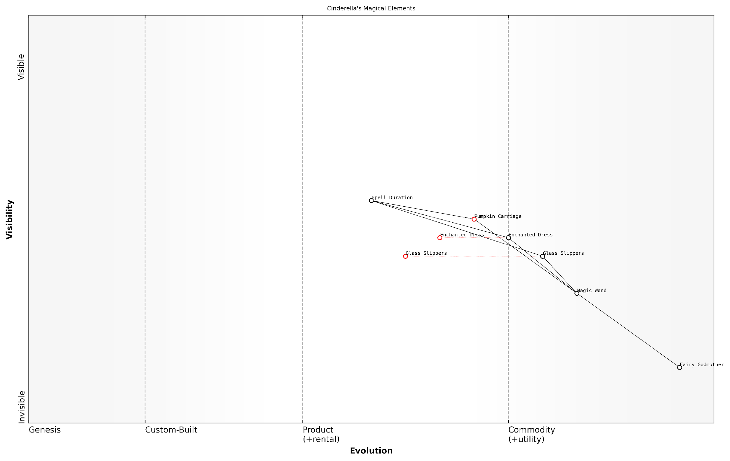

*Draft Wardley Map: [Insert Wardley Map: Mapping the magical elements]*

[Edit this draft Wardley Map](https://create.wardleymaps.ai/#clone:893b16e3c50efa8751)

Wardley Map Assessment

The Cinderella’s Magical Elements map reveals a well-structured but centralised magical system with clear progression from unique to more standardised components. The strategic focus should be on addressing the time limitation constraint, diversifying magical sources, and gradually evolving towards more sustainable and user-controlled magic while maintaining the unique charm of key elements like the Glass Slippers. There’s significant potential for innovation in making magic more accessible and customizable, which could lead to new story possibilities and expanded magical ecosystems.

[View full Wardley Map report](http://markdown_wardley_map_reports/wardley_map_report_24_Mapping_the_magical_elements.md)

### Understanding evolution in Cinderella’s world

As we map Cinderella’s journey, we can see how different elements in her world evolve over time. This evolution helps us understand the changing landscape of her story and the strategic moves that lead to her happy ending.

* Cinderella’s status: From servant to princess
* Cinderella’s clothing: From rags to a magical gown
* Transportation: From walking to a magical pumpkin carriage
* Cinderella’s shoes: From worn-out to glass slippers

Each of these elements represents a component on our map that evolves throughout the story. For example, Cinderella’s status moves from the left side of our map (genesis) to the right side (commodity) as she becomes more recognised and valued in her world.

A wise fairy godmother once said, ‘Magic is simply the evolution of possibility into reality.’

By understanding this evolution, we can see how Cinderella’s world transforms and how each change contributes to her ultimate goal of finding happiness and love.

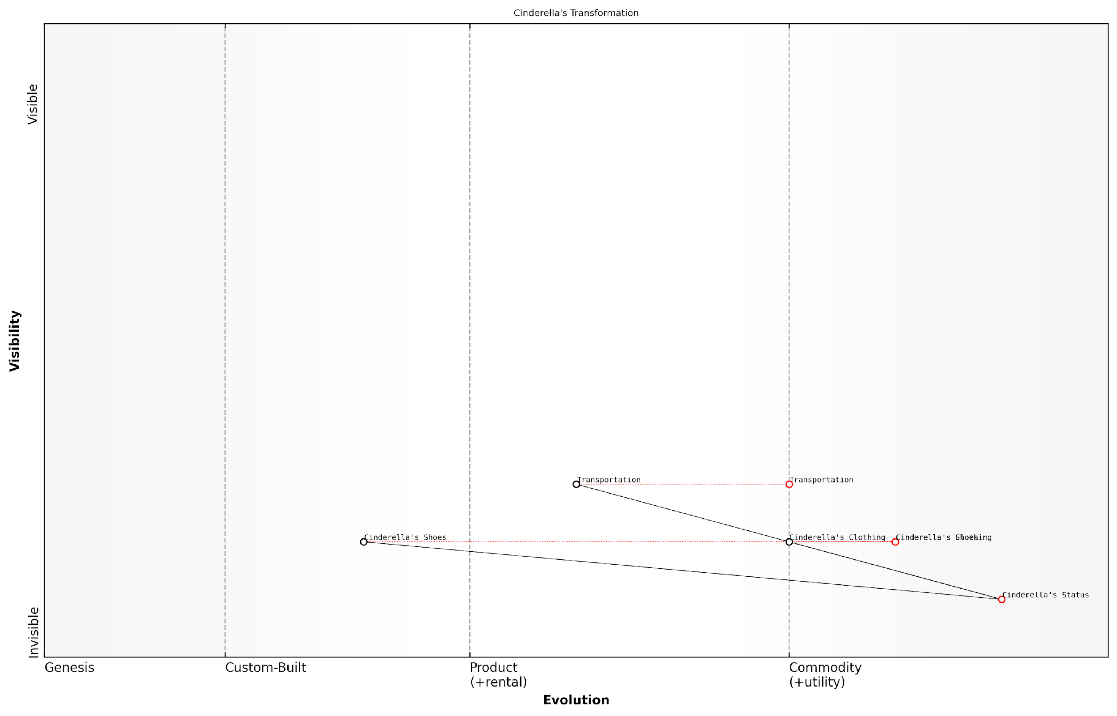

*Draft Wardley Map: [Insert Wardley Map: Understanding evolution in Cinderella’s world]*

[Edit this draft Wardley Map](https://create.wardleymaps.ai/#clone:5f93c2bacc39efce3f)

Wardley Map Assessment

This Wardley Map of Cinderella’s transformation reveals a strategy centred on rapid, externally-driven change to achieve a shift in social status. While effective for the immediate goal of attending the ball, the reliance on temporary, magical solutions suggests potential long-term vulnerabilities. Future strategies should focus on developing more sustainable means of status improvement and personal empowerment, while leveraging the unique advantages gained from this magical intervention. The interplay between magical and mundane elements offers rich opportunities for innovation and storytelling, potentially shifting the narrative towards themes of personal growth and societal change beyond the traditional fairy tale ending.

[View full Wardley Map report](http://markdown_wardley_map_reports/wardley_map_report_25_Understanding_evolution_in_Cinderella's_world.md)

## Lessons from Cinderella’s Map

### The power of transformation

Cinderella’s magical transformation teaches us valuable lessons about the power of change in our lives and on our maps. Just as Cinderella’s world was transformed by magic, our maps can show us how things can change and evolve over time.

* Change can happen quickly: Cinderella’s transformation from rags to a beautiful gown happened in an instant. On our maps, we can see how some things can change rapidly too.
* Small changes can have big effects: A simple pair of glass slippers changed Cinderella’s whole life. Our maps can show how small innovations can lead to big changes in how things work.
* Transformation can open new opportunities: Cinderella’s new appearance allowed her to go to the ball. Our maps can reveal new possibilities when things evolve or change.

By understanding the power of transformation on our maps, we can better prepare for changes in our own lives and the world around us. We can look for opportunities to make positive changes and be ready to adapt when things evolve.

As a wise fairy godmother once said, ‘Even the smallest change can lead to the most wonderful adventures.’

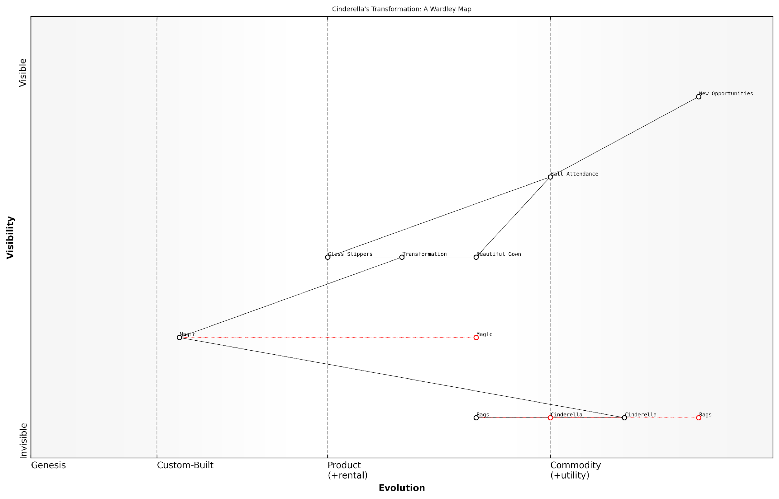

*Draft Wardley Map: [Insert Wardley Map: The power of transformation]*

[Edit this draft Wardley Map](https://create.wardleymaps.ai/#clone:b74d8d5b3eed15c00a)

Wardley Map Assessment

The map represents a powerful transformation journey with a unique competitive advantage in Magic. However, there’s a need to evolve this advantage, make transformations more sustainable, and diversify opportunities to maintain long-term strategic relevance in the Fairy Tale World. The key focus should be on developing internal magical capabilities, enhancing the transformation process, and creating a broader range of high-value opportunities.

[View full Wardley Map report](http://markdown_wardley_map_reports/wardley_map_report_26_The_power_of_transformation.md)

### Recognising opportunities

Cinderella’s map teaches us an important lesson about recognising opportunities. In the story, Cinderella’s chance to attend the ball seems magical, but in our map, we can see it as a strategic opportunity that arose from her situation.

* Look for unexpected resources: The Fairy Godmother represents unexpected help or resources that can change your situation.
* Be prepared: Cinderella was ready to seize her opportunity when it came, even though it was unexpected.
* Recognise value in everyday things: Pumpkins and mice became valuable assets when viewed creatively.

By mapping out Cinderella’s journey, we can see how different elements came together to create her opportunity. This teaches us to look at our own situations in new ways, seeking out chances for positive change that we might otherwise miss.

As a wise business leader once said, ‘Opportunity is missed by most people because it is dressed in overalls and looks like work.’

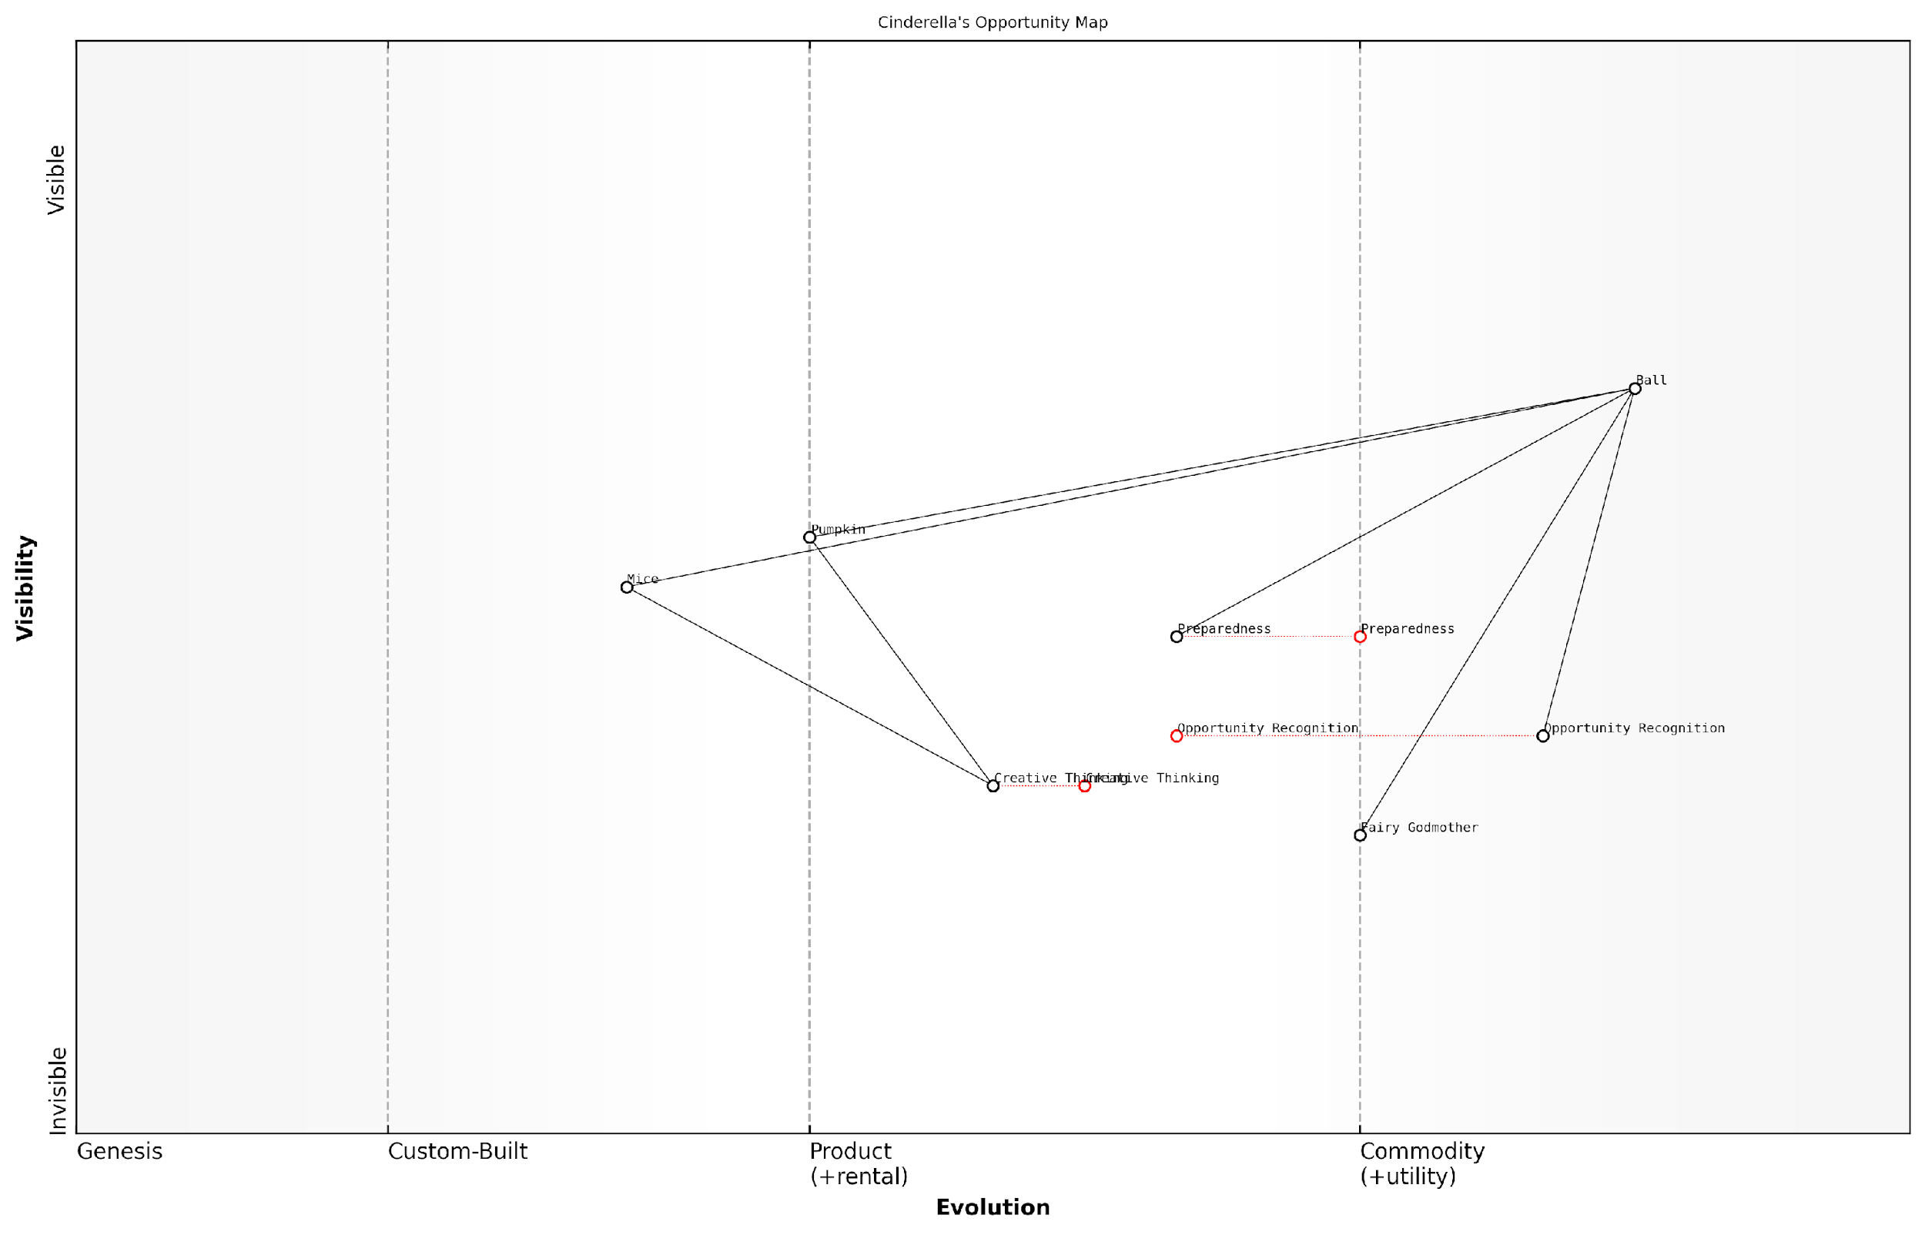

*Draft Wardley Map: [Insert Wardley Map: Recognizing opportunities]*

[Edit this draft Wardley Map](https://create.wardleymaps.ai/#clone:0a764a6eda723bbeab)

Wardley Map Assessment

This Wardley Map represents a system focused on recognizing and capitalising on transformative opportunities. It highlights the importance of creative thinking, preparedness, and the ability to repurpose existing resources. The strategic position is strong in terms of opportunity recognition but relies heavily on external magical intervention. Future success will depend on evolving creative thinking and preparedness capabilities, potentially internalising the transformative powers currently provided by the Fairy Godmother. The unique approach to resource transformation (Pumpkin, Mice) offers a competitive advantage that could be further leveraged. Overall, the system shows promise but needs to focus on developing more structured, replicable processes to ensure consistent success in recognizing and seizing opportunities.

[View full Wardley Map report](http://markdown_wardley_map_reports/wardley_map_report_27_Recognizing_opportunities.md)

### The importance of timing

In Cinderella’s story, timing plays a crucial role in her transformation and success. This aspect of the fairy tale offers valuable lessons about the importance of timing in strategic planning and decision-making.

* The magical transformation occurs at the right moment, just before the ball
* Cinderella must return before midnight, when the spell wears off
* The prince’s search with the glass slipper happens at the perfect time to find Cinderella

When we map Cinderella’s journey, we can see how timing affects each component of her transformation. The fairy godmother’s magic represents a sudden shift in available resources, much like a new technology or opportunity in the real world. Cinderella’s ability to seize this moment demonstrates the importance of being prepared and aware of changes in our environment.

A wise business leader once said, ‘Timing is everything. The right idea at the wrong time will fail, but an ordinary idea at the right time can change the world.’

In our own lives and projects, we can learn from Cinderella’s map to identify key moments of opportunity and potential transformation. By understanding the evolution of components in our map, we can better predict when these crucial moments might occur and be ready to act when they do.

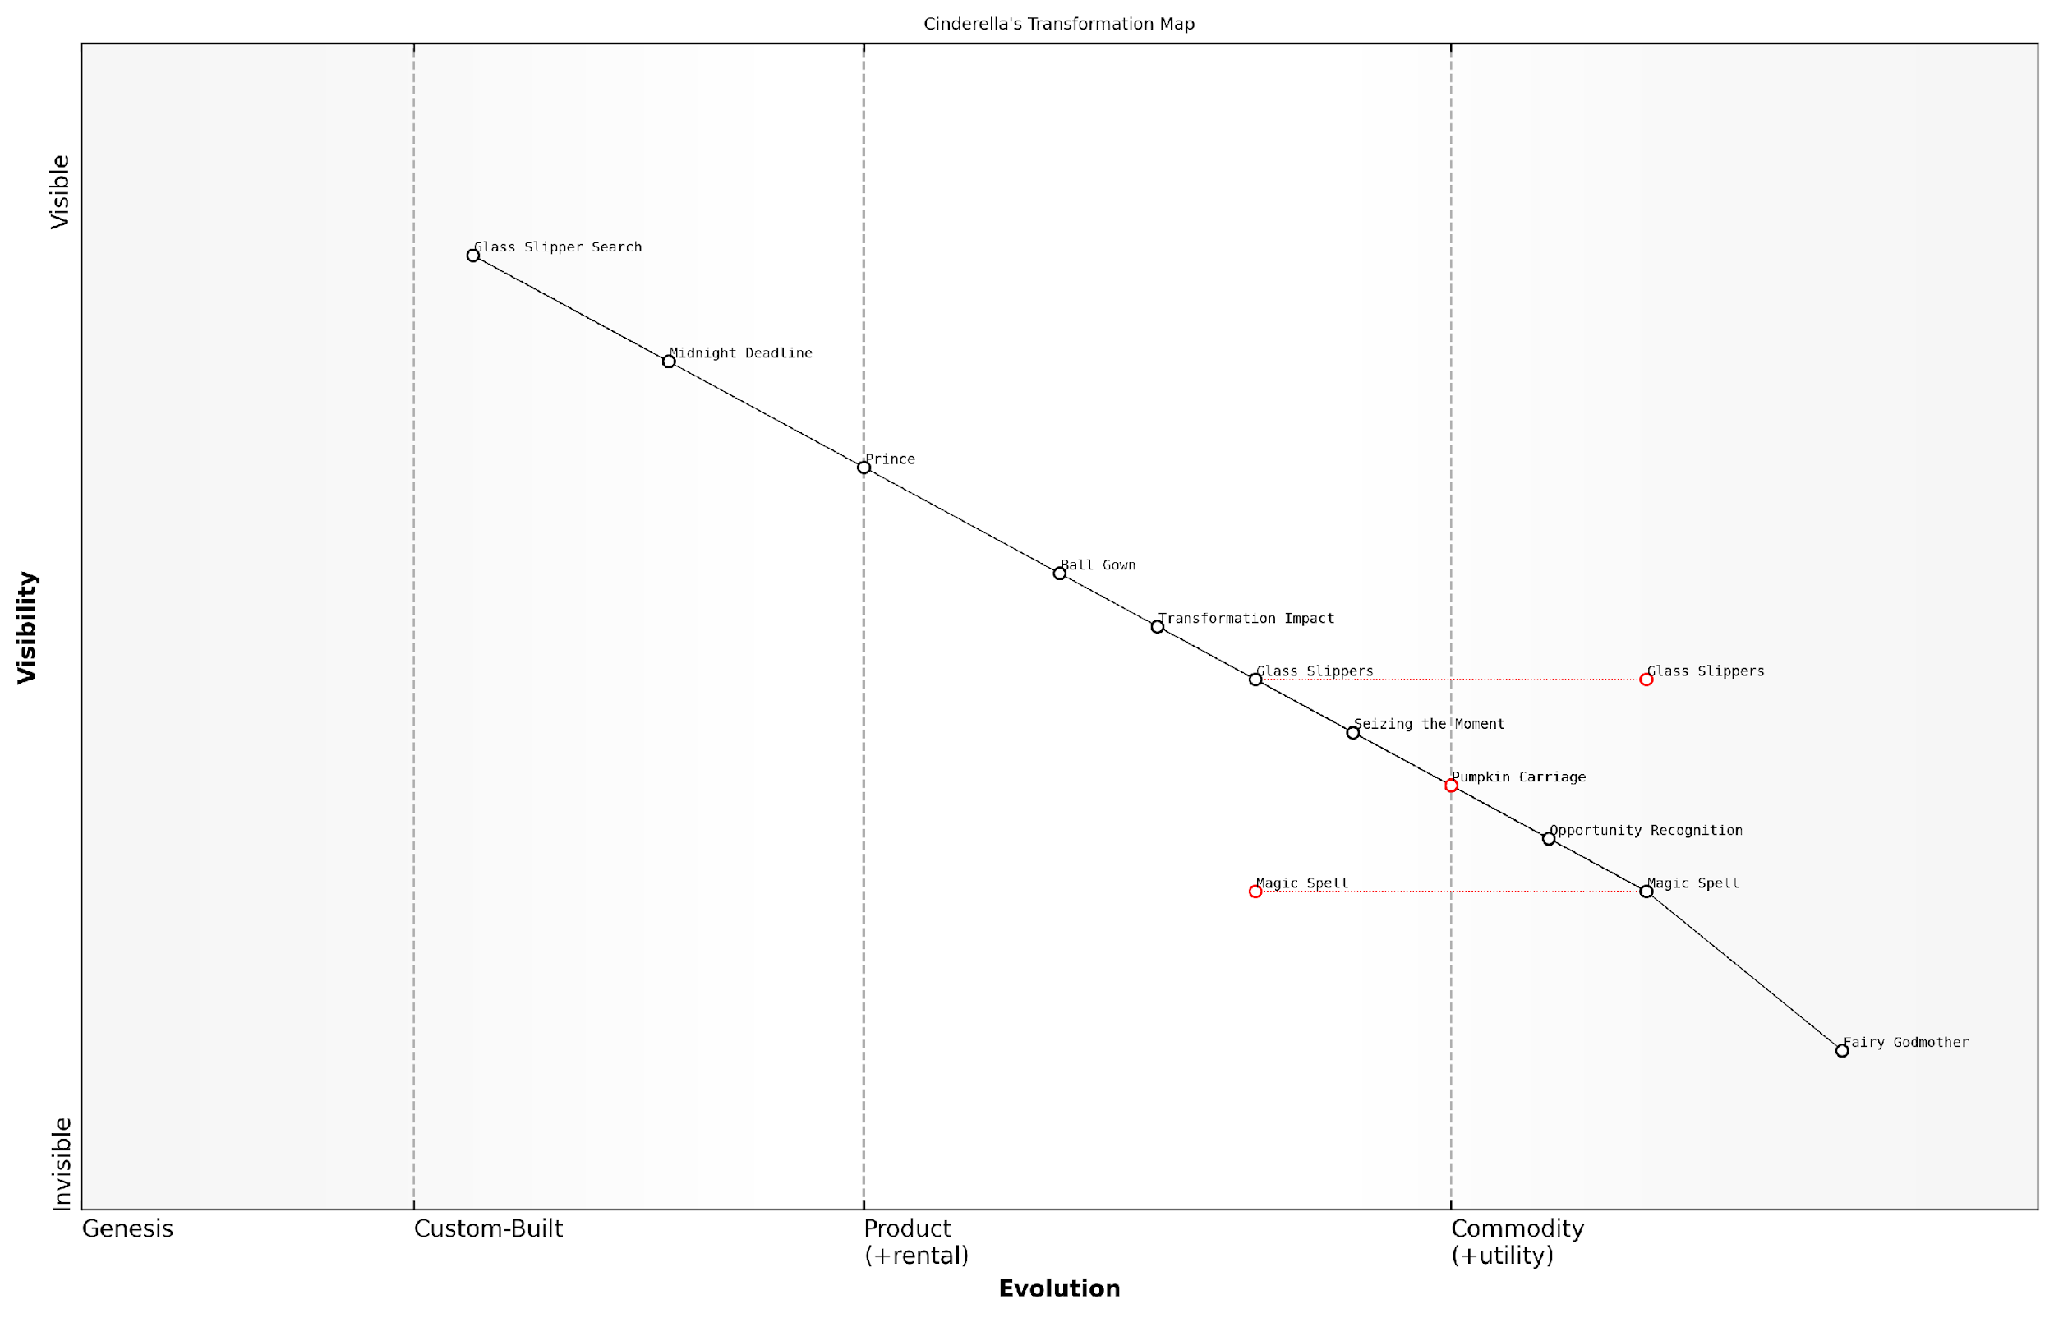

*Draft Wardley Map: [Insert Wardley Map: The importance of timing]*

[Edit this draft Wardley Map](https://create.wardleymaps.ai/#clone:8fc3229c6717927941)

Wardley Map Assessment

This map illustrates a powerful but potentially unsustainable transformation process, highlighting the critical importance of timing and unique identifiers in seizing life-changing opportunities. While effective in the short term, the strategy relies heavily on external intervention and operates under strict time constraints. Future success will depend on developing more sustainable, self-driven transformation capabilities and building a broader network of opportunities beyond the initial catalyst event.

[View full Wardley Map report](http://markdown_wardley_map_reports/wardley_map_report_28_The_importance_of_timing.md)

# Chapter 4: Jack’s Beanstalk Business Venture

## The Tale of Jack and the Beanstalk

### A child-friendly version

Once upon a time, there was a boy named Jack who lived with his mother. They were very poor and had only one cow left. One day, Jack’s mother told him to take the cow to the market and sell it.

On the way to the market, Jack met a funny old man who offered to trade some magic beans for the cow. Jack thought this was exciting and made the trade. When he got home, his mother was very upset and threw the beans out of the window.

The next morning, Jack woke up to find a giant beanstalk growing outside his window. He climbed up the beanstalk and found himself in a magical land in the clouds. There, he discovered a giant’s castle.

* Jack found a bag of gold coins in the castle
* He also found a magic hen that laid golden eggs
* Finally, he found a magical singing harp

Each time Jack took something, he had to run away from the angry giant. On his last trip, Jack chopped down the beanstalk as the giant tried to follow him. The beanstalk fell, and the giant was never seen again.

With the gold coins, the magic hen, and the singing harp, Jack and his mother were no longer poor. They lived happily ever after, and Jack learnt that sometimes taking risks can lead to great rewards.

‘In every challenge lies an opportunity for those brave enough to seek it,’ a wise storyteller once said.

### Important elements of the story

Jack and the Beanstalk is a classic fairy tale that teaches children about risk, reward, and the consequences of our actions. In this child-friendly version, we’ll focus on the key elements that make this story perfect for introducing Wardley Mapping concepts.

* Jack, a poor boy who lives with his mother
* The magic beans Jack receives in exchange for the family cow
* The giant beanstalk that grows overnight
* The giant’s castle in the sky
* The golden goose and other treasures
* The giant who chases Jack
* Jack’s clever escape and the beanstalk’s destruction

These elements provide a rich foundation for exploring concepts like value chains, evolution of components, and strategic decision-making. As we map Jack’s journey, we’ll see how each part of the story relates to different aspects of Wardley Mapping.

A wise business leader once said, ‘Sometimes, the greatest opportunities come from taking calculated risks and venturing into uncharted territories.’

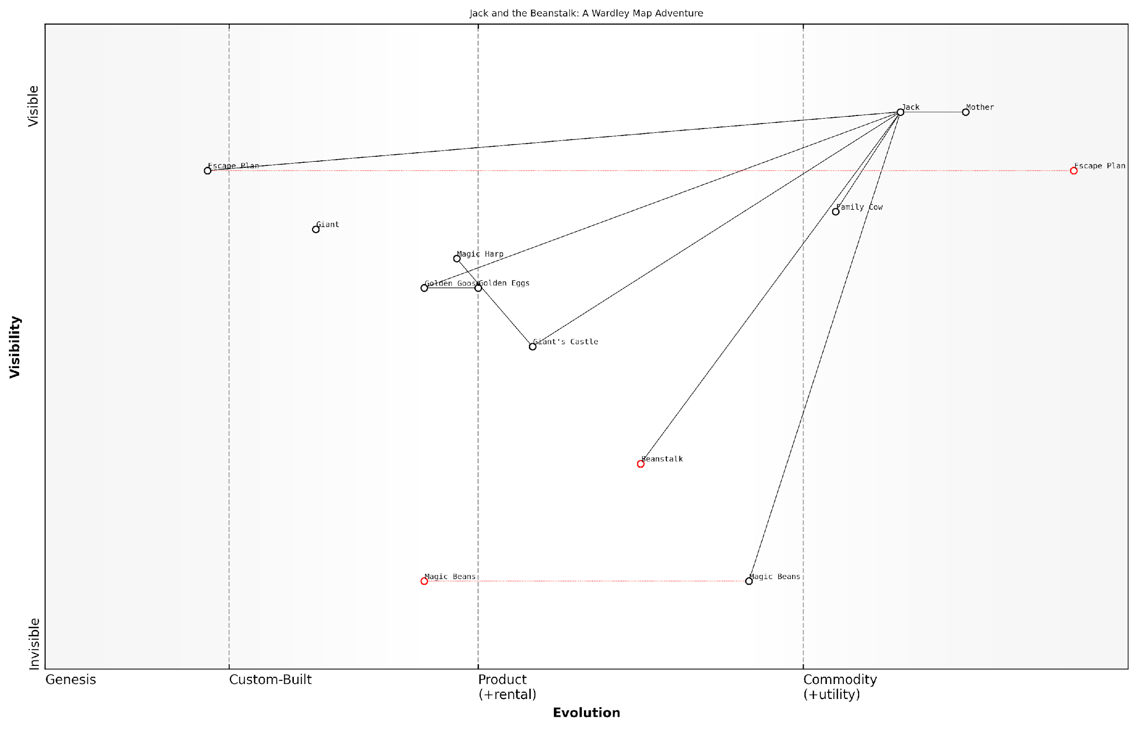

*Draft Wardley Map: [Insert Wardley Map: Important elements of the story]*

[Edit this draft Wardley Map](https://create.wardleymaps.ai/#clone:fed3ced7cd32bba018)

Wardley Map Assessment

The Wardley Map of Jack and the Beanstalk reveals a high-risk, high-reward venture with significant potential for value creation. Jack’s strategic position and unique access to magical resources provide a strong competitive advantage. However, the reliance on a single, high-risk path (the Beanstalk) and the presence of a powerful antagonist (the Giant) present significant challenges. The key to long-term success lies in leveraging current advantages while developing sustainable practices and mitigating risks. Future strategies should focus on diversifying magical assets, improving access to the magical realm, and creating a robust ecosystem that bridges the mundane and magical worlds.

[View full Wardley Map report](http://markdown_wardley_map_reports/wardley_map_report_30_Important_elements_of_the_story.md)

## Mapping Jack’s Adventure

### Identifying Jack’s needs

To begin mapping Jack’s adventure, we first need to identify his needs. In the story, Jack’s primary needs are quite clear and relatable to children:

* Food for his family
* Money to buy necessities
* A way to help his mother
* Adventure and excitement

These needs drive Jack’s actions throughout the story. When we map them, we can see how they relate to the components of his journey:

* The cow represents a potential source of food and money
* The magic beans are an opportunity for adventure
* The beanstalk is a path to new possibilities
* The giant’s castle contains valuable items that could solve Jack’s problems

By understanding Jack’s needs, we can start to see how the different elements of the story fit together on our map. This helps us analyse Jack’s decision-making process and the consequences of his choices.

A wise business strategist once said, ‘Understanding the needs of your users is the first step in creating a successful strategy.’

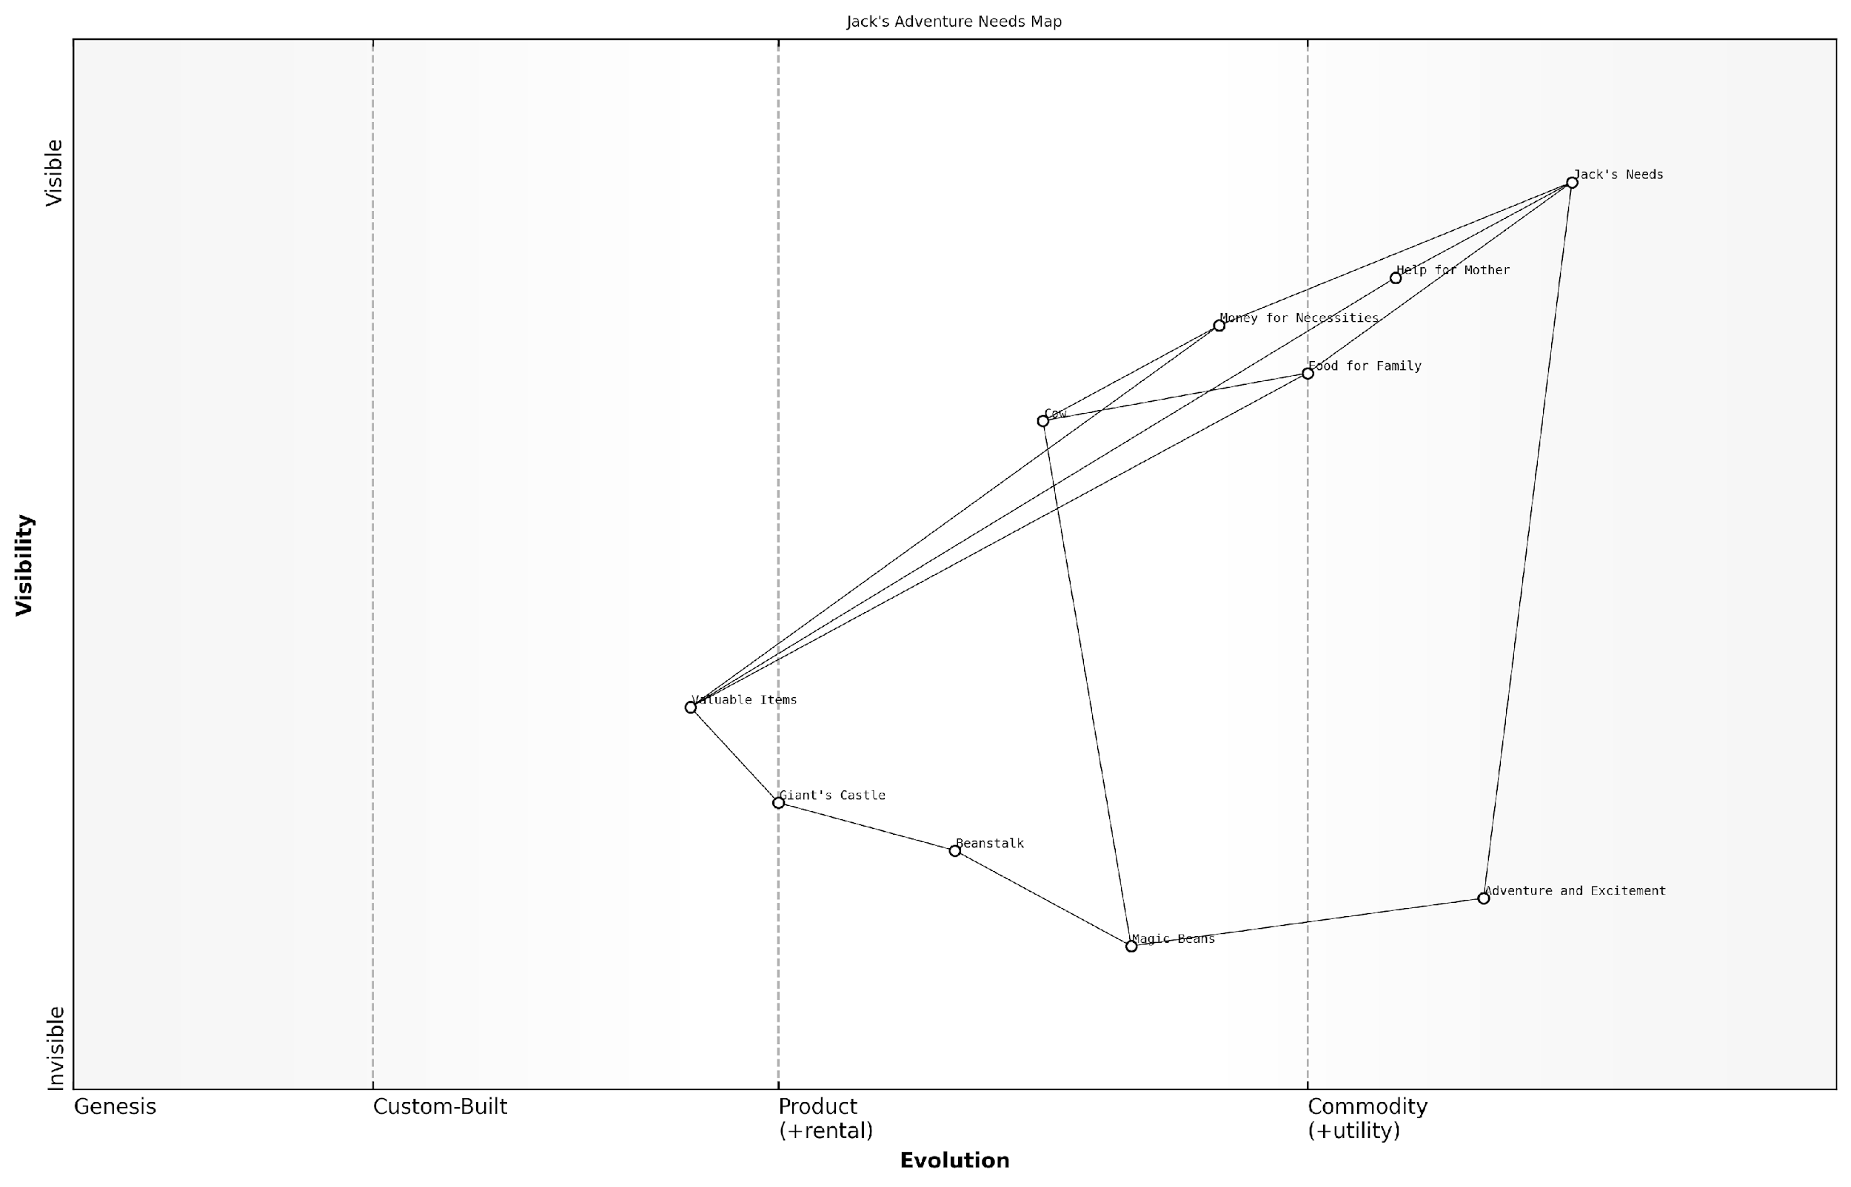

*Draft Wardley Map: [Insert Wardley Map: Identifying Jack’s needs]*

[Edit this draft Wardley Map](https://create.wardleymaps.ai/#clone:9a856fc33d5d9efdd6)

Wardley Map Assessment

This map represents a unique blend of basic survival needs and magical opportunities. The strategic position is strong due to exclusive access to valuable magical resources, but vulnerable due to the reliance on a single, risky venture. The key to long-term success lies in stabilising the magical supply chain, diversifying adventure sources, and developing sustainable relationships with the giant realm. Innovation in beanstalk technology and giant diplomacy could open up entirely new markets and opportunities beyond the initial treasure acquisition. Overall, the map suggests a high-risk, high-reward scenario with significant potential for growth and transformation of the entire fairy tale ecosystem.

[View full Wardley Map report](http://markdown_wardley_map_reports/wardley_map_report_31_Identifying_Jack's_needs.md)

### Mapping the components of Jack’s journey

Now that we’ve heard Jack’s story, let’s map out his adventure using a Wardley Map. We’ll start by identifying the key components of Jack’s journey and placing them on our map.

* Jack (our user)
* Magic beans
* Beanstalk
* Giant’s castle
* Golden eggs
* Magic harp
* Giant

We’ll place these components on our map based on how visible they are to Jack (our user) and how evolved they are. For example, the magic beans start as something new and uncertain, whilst the golden eggs are a well-known valuable item.

As we look at our map, we can see how Jack’s journey evolves. The magic beans lead to the beanstalk, which allows Jack to reach the giant’s castle. This opens up new opportunities for Jack to obtain valuable items like the golden eggs and the magic harp.

A wise business mentor once said, ‘Sometimes the most valuable opportunities come from taking risks on things that others might overlook.’

By mapping out Jack’s adventure, we can see how each component plays a crucial role in his journey. This helps us understand how different elements in a story (or in real life) can connect and lead to new opportunities.

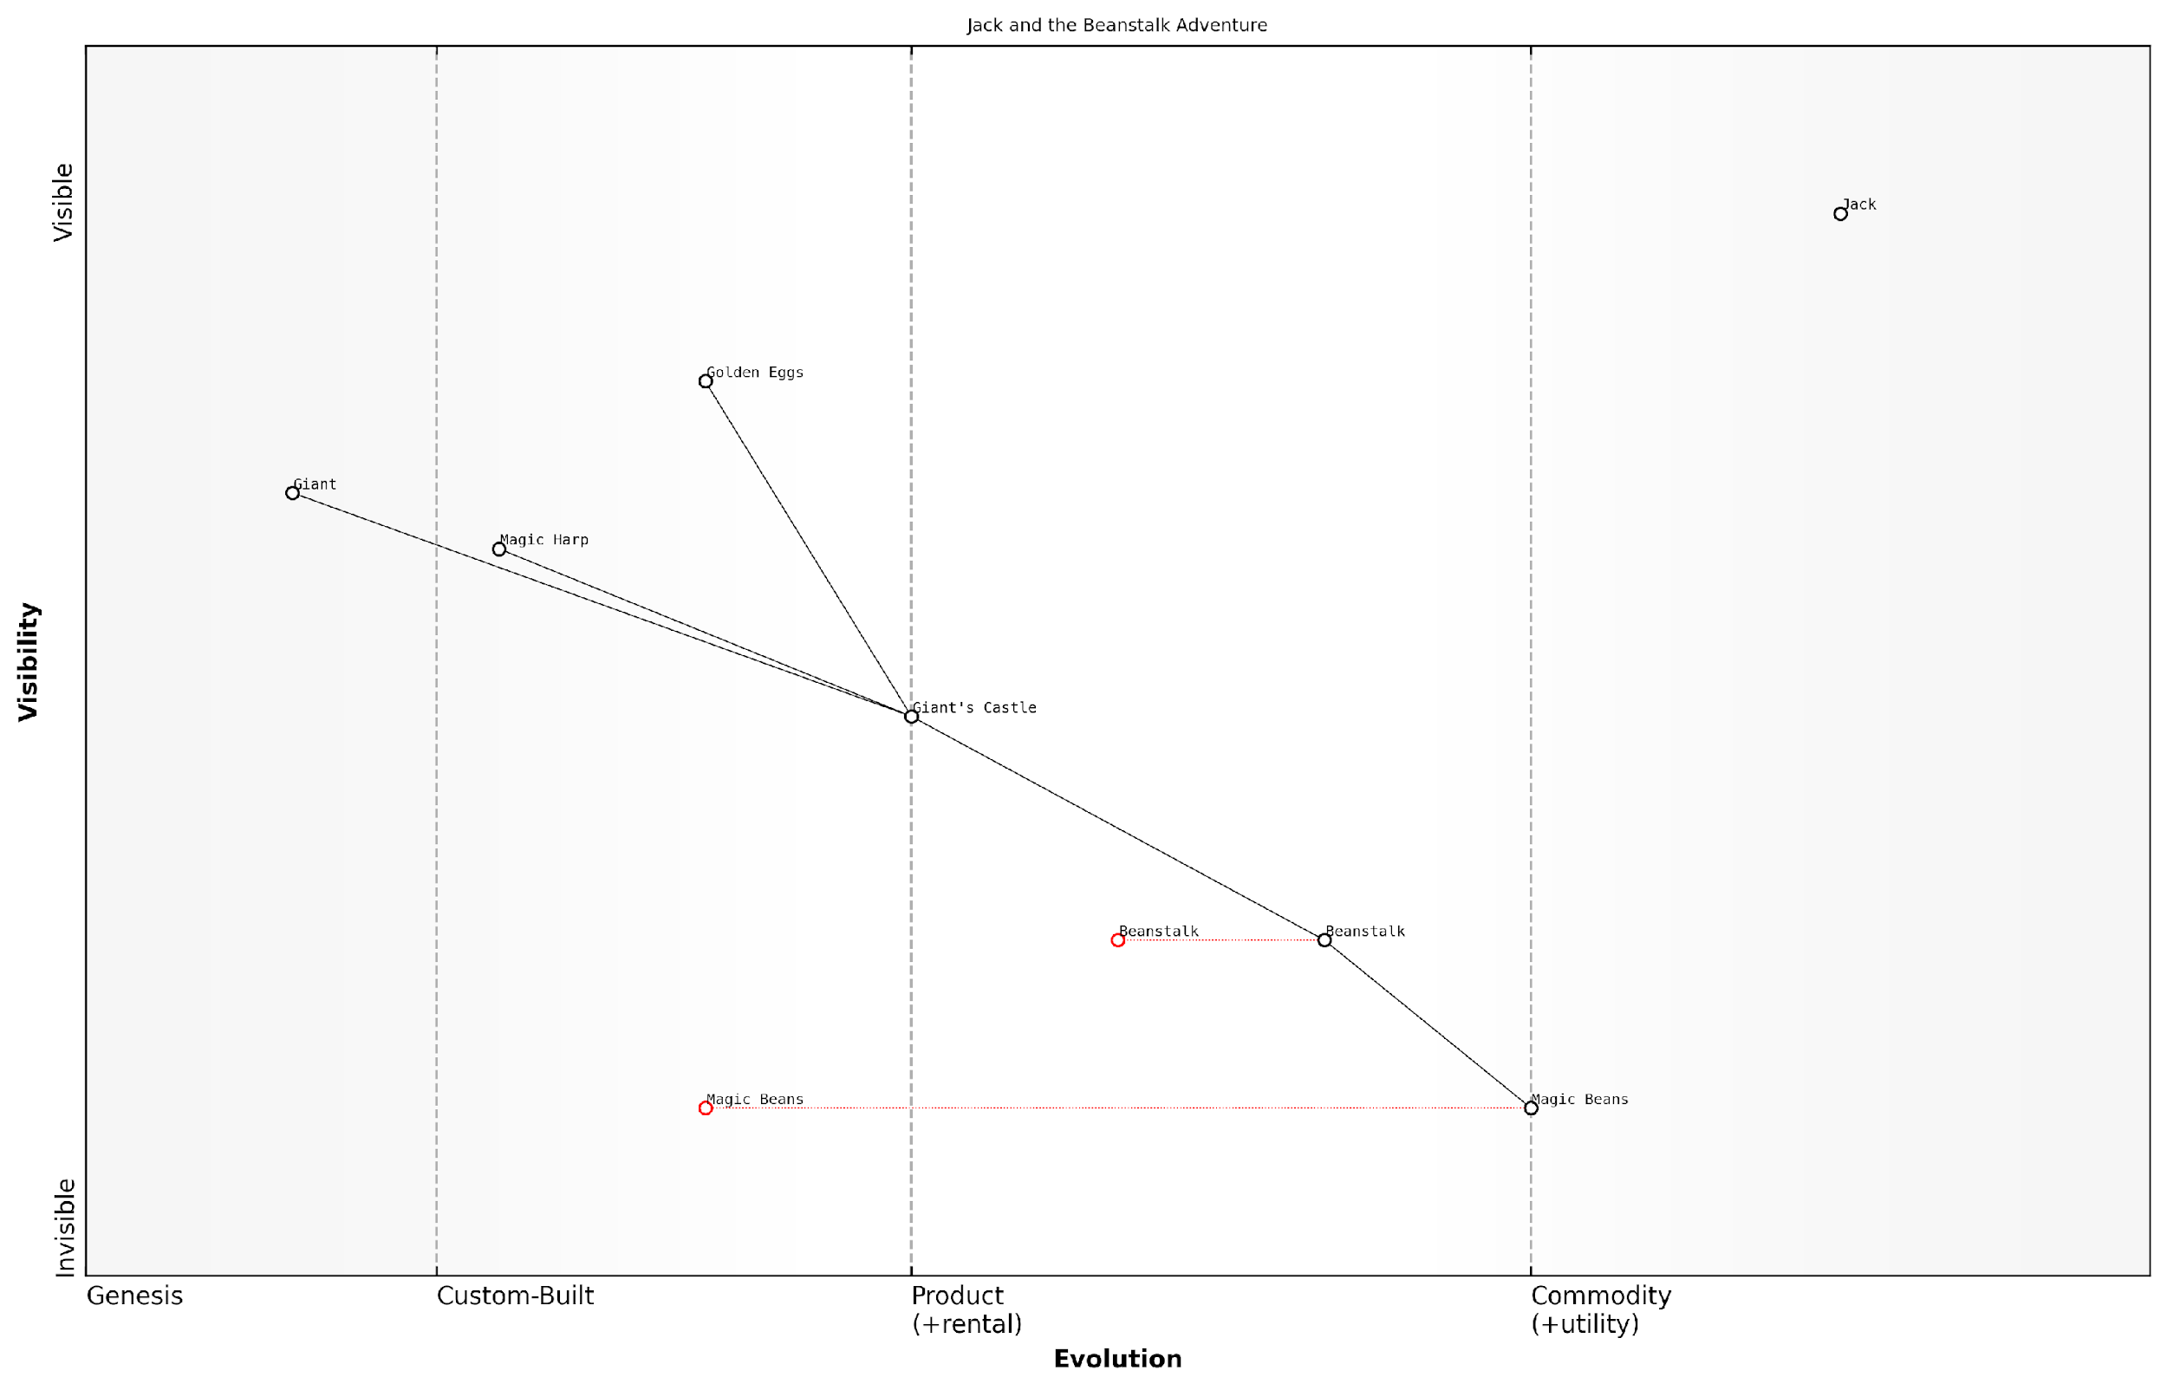

*Draft Wardley Map: [Insert Wardley Map: Mapping the components of Jack’s journey]*

[Edit this draft Wardley Map](https://create.wardleymaps.ai/#clone:14085400686589baaf)

Wardley Map Assessment

The map represents a high-risk, high-reward venture centred around accessing and extracting value from a magical realm. The strategic focus should be on stabilising and optimising the path to value (Beans -> Beanstalk -> Castle), while developing capabilities to manage risks (Giant) and maximise the potential of acquired assets (Eggs, Harp). Long-term success will depend on innovating within this magical ecosystem and potentially transforming one-time adventure into a sustainable, repeatable process.

[View full Wardley Map report](http://markdown_wardley_map_reports/wardley_map_report_32_Mapping_the_components_of_Jack's_journey.md)

### Exploring evolution in Jack’s world

As we map Jack’s adventure, we can see how different elements in his world evolve over time. Let’s explore how the components of Jack’s journey change and develop throughout the story.

* Magic beans: From unknown to valuable
* Beanstalk: From seed to giant plant
* Giant’s castle: From mysterious to explored
* Golden eggs: From rare treasure to potential business

The magic beans start as an unknown and seemingly worthless item, but they quickly evolve into something of great value once their true nature is revealed. This shows how innovation can change the perceived value of things.

The beanstalk itself undergoes a rapid evolution, growing from a tiny seed into an enormous plant that reaches the clouds. This represents how small ideas can grow into big opportunities if given the right conditions.

The giant’s castle moves from being a mysterious and unknown place to a location that Jack explores and understands. This evolution represents how unknown markets or opportunities can become familiar with exploration and experience.

Finally, the golden eggs evolve from being a rare and magical treasure to a potential ongoing business opportunity for Jack and his mother. This shows how a single valuable discovery can turn into a sustainable venture.

As a successful entrepreneur once said, ‘The most valuable skill is the ability to see how things might evolve and position yourself accordingly.’

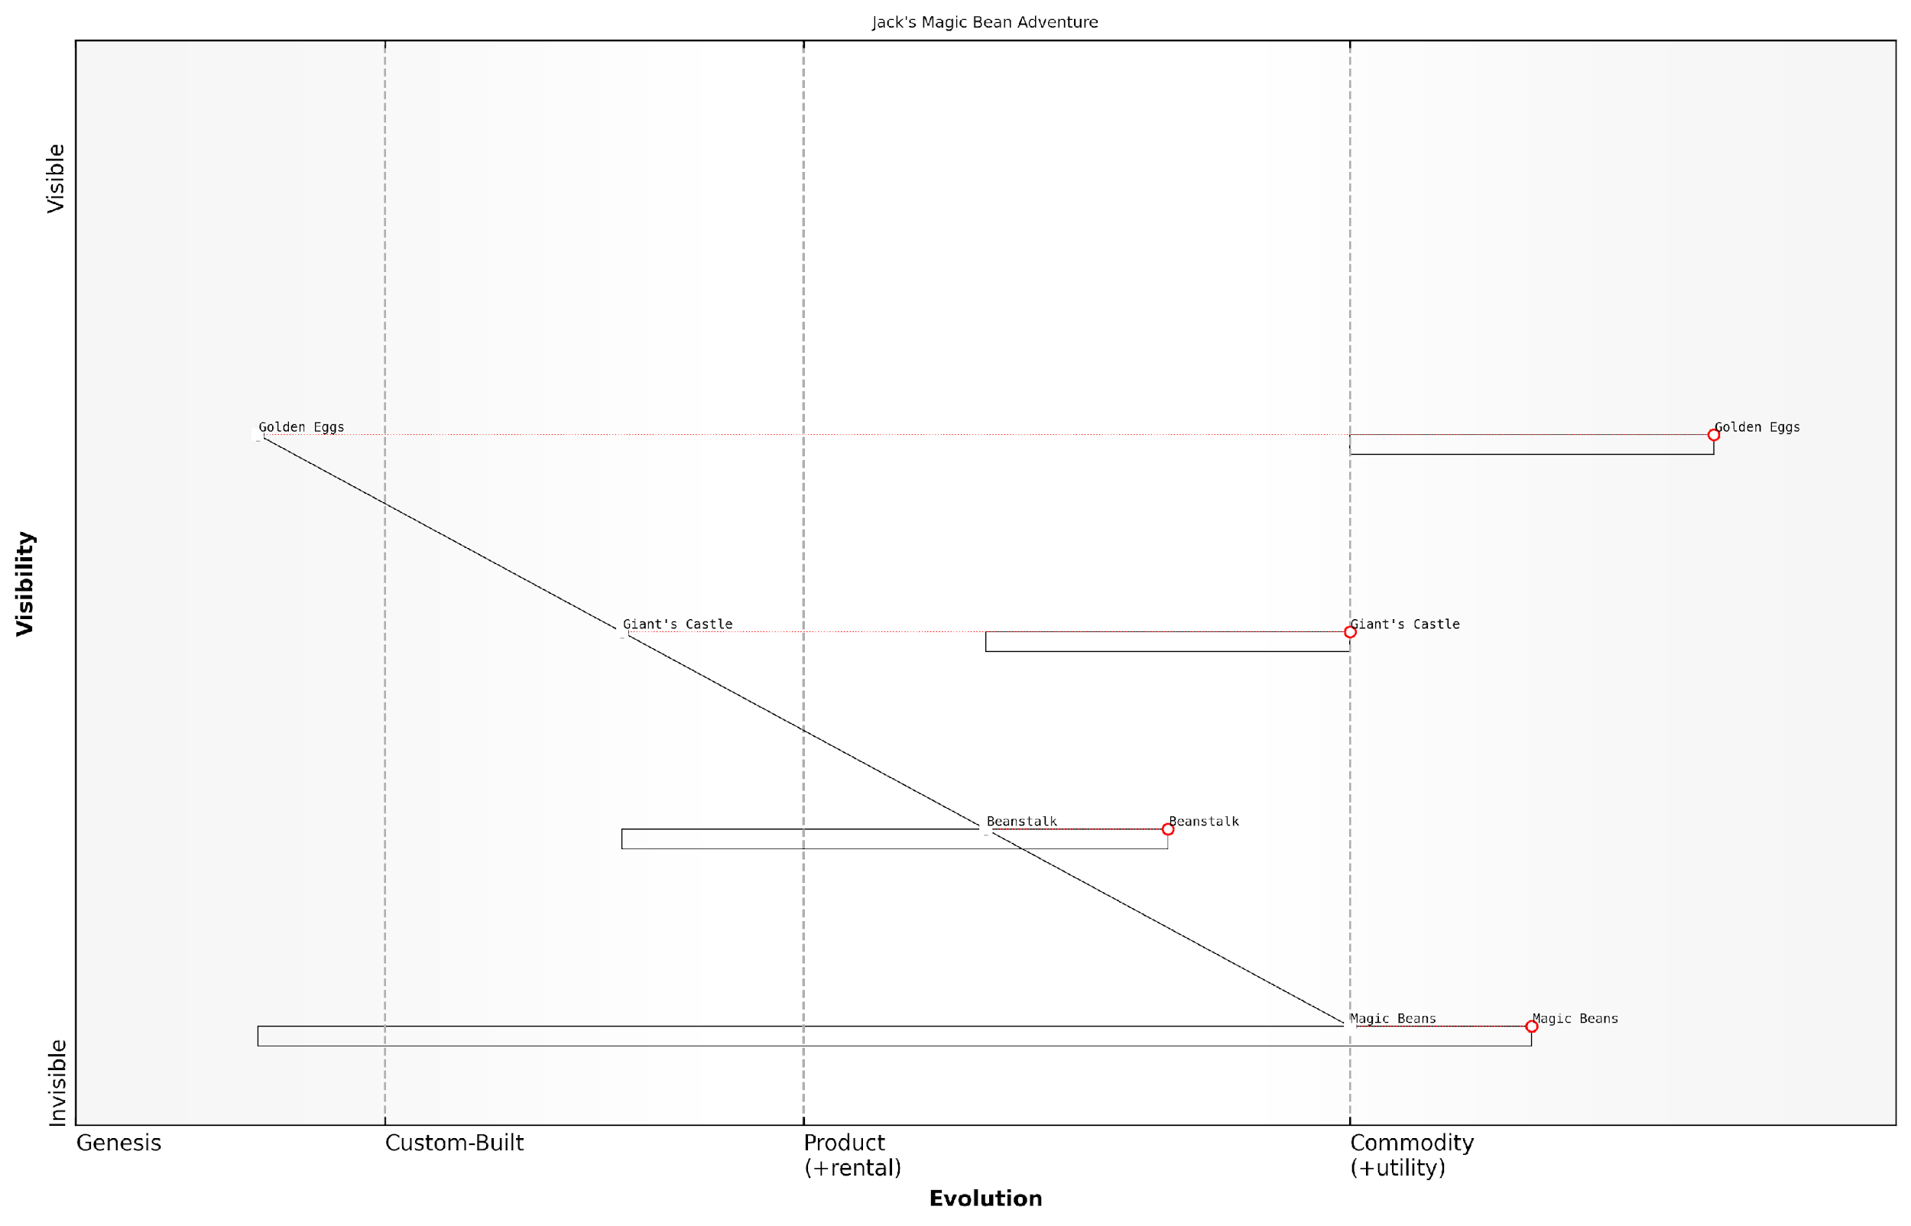

*Draft Wardley Map: [Insert Wardley Map: Exploring evolution in Jack’s world]*

[Edit this draft Wardley Map](https://create.wardleymaps.ai/#clone:fce8f1f61f61b7edfb)

Wardley Map Assessment

Jack’s Magic Bean Adventure represents a unique business opportunity with a clear value chain from novel input to valuable output. The key to success lies in optimising each stage of the journey, from enhancing Magic Bean potential to innovating around Golden Egg applications. By focusing on capability development, especially in Beanstalk growth and Castle navigation, and by building a strong ecosystem of partners, this venture can evolve from a fairy tale concept to a robust, innovative business model. The rapid evolution of components suggests a dynamic market with significant potential for first-mover advantages and disruptive innovation.

[View full Wardley Map report](http://markdown_wardley_map_reports/wardley_map_report_33_Exploring_evolution_in_Jack's_world.md)

## Insights from Jack’s Map

### Taking calculated risks

Jack’s adventure up the beanstalk teaches us valuable lessons about taking calculated risks in our own lives and future business ventures. By mapping out Jack’s journey, we can see how he weighed the potential rewards against the dangers he faced.

* Assess the situation: Jack looked at the giant beanstalk and considered his options before climbing.
* Understand the potential rewards: Jack knew there might be valuable treasures at the top of the beanstalk.
* Be aware of the risks: Jack recognised the danger of encountering a giant.
* Have a backup plan: Jack made sure he could quickly climb down the beanstalk if needed.

In our own lives, we can apply these same principles when facing new opportunities or challenges. It’s important to gather information, consider the possible outcomes, and have a plan for both success and potential setbacks.

A wise business leader once said, ‘The biggest risk is not taking any risk. In a world that’s changing quickly, the only strategy that is guaranteed to fail is not taking risks.’

By using our Wardley Map of Jack’s adventure, we can see how different components of his journey were positioned and how they evolved. This helps us understand how to approach risks in our own lives, balancing the potential for growth and success with careful planning and preparation.

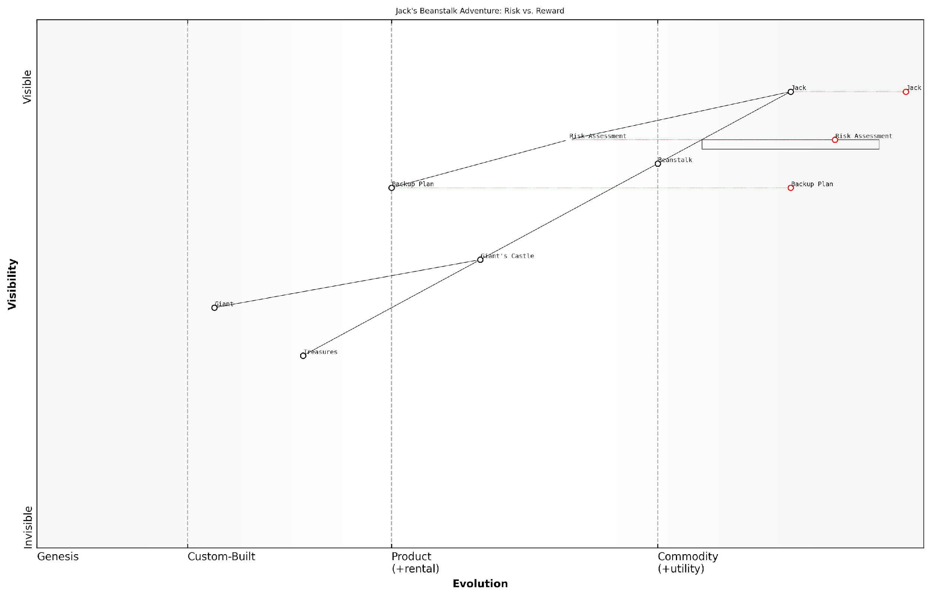

*Draft Wardley Map: [Insert Wardley Map: Taking calculated risks]*

[Edit this draft Wardley Map](https://create.wardleymaps.ai/#clone:dea661ab95011990a2)

Wardley Map Assessment

This Wardley Map illustrates a high-risk, high-reward scenario where success hinges on balancing known strengths with unknown challenges. The strategic position is strong in terms of the protagonist’s experience and risk assessment capabilities, but faces significant uncertainties in the key objective areas. The primary strategic focus should be on leveraging advanced risk management and adaptable planning to navigate the uncertainties, while continuously seeking to improve visibility and control over the less predictable elements. Long-term success will likely depend on innovative approaches to gathering intelligence, enhancing climbing capabilities, and developing more sophisticated predictive models for risk and reward assessment.

[View full Wardley Map report](http://markdown_wardley_map_reports/wardley_map_report_34_Taking_calculated_risks.md)

### The value of unique resources

Jack’s magical beanstalk adventure teaches us an important lesson about the value of unique resources. In the world of business and problem-solving, having something special that others don’t can make a big difference.

* Magic beans: Jack’s special beans were unlike anything else in his village. They represent a unique opportunity or resource that others might not see value in at first.
* Giant’s treasures: The golden eggs and magic harp in the giant’s castle were rare and valuable. They show how unique resources can lead to great rewards.
* Beanstalk itself: The growing beanstalk provided Jack with access to a new world. It reminds us that sometimes our unique resources can open doors to unexpected opportunities.

When we map out Jack’s journey, we can see how these unique resources played a crucial role in his success. They allowed him to do things that others couldn’t, giving him an advantage.

A wise business leader once said, ‘It’s not just about having resources, it’s about having resources that set you apart from others.’

In our own lives, we can look for our own ‘magic beans’ - special skills, ideas, or opportunities that others might not see value in. By recognising and using these unique resources, we can create our own path to success, just like Jack did with his beanstalk.

### Balancing ethics and opportunity

Jack’s adventure up the beanstalk presents an interesting dilemma that many children (and adults) can relate to - the balance between seizing an opportunity and making ethical choices. By mapping Jack’s journey, we can explore this concept in a way that’s accessible to young minds.

* Identifying ethical considerations on the map
* Mapping the potential consequences of Jack’s actions
* Exploring alternative paths that balance ethics and opportunity

On our map, we can place ‘ethical decision making’ as a key component that influences Jack’s actions. This helps children understand that ethics should be a consideration in any venture or opportunity.

A wise business leader once said, ‘Success without integrity is failure.’

By examining the map, we can see how Jack’s choices impact not only himself but also others, including the giant and his family. This teaches children to consider the wider implications of their actions.

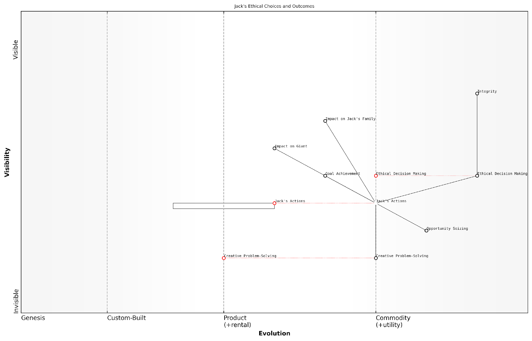

*Draft Wardley Map: [Insert Wardley Map: Balancing ethics and opportunity]*

[Edit this draft Wardley Map](https://create.wardleymaps.ai/#clone:79c3a7c10b0563b5e6)

Wardley Map Assessment

This Wardley Map reveals a complex ethical landscape in Jack’s beanstalk venture, highlighting the tension between seizing magical opportunities and maintaining moral integrity. The strategic position emphasises the critical importance of ethical decision-making and creative problem-solving in navigating this fantastical business environment. The map suggests significant opportunities for innovation in ethical magical ventures, while also highlighting the risks of moral compromise and potential negative impacts on other entities like the Giant. Moving forward, Jack’s success will likely depend on his ability to develop sustainable, ethically-sound business models that balance personal gain with broader positive impacts, potentially through collaborative approaches with other ecosystem participants. The evolving nature of key components such as Ethical Decision Making and Creative Problem-Solving indicates a dynamic environment where continuous innovation and adaptation will be crucial for long-term success.

[View full Wardley Map report](http://markdown_wardley_map_reports/wardley_map_report_36_Balancing_ethics_and_opportunity.md)

Ultimately, the map can help children brainstorm ways Jack could have achieved his goals (opportunity) while still making ethical choices. This exercise encourages creative problem-solving and reinforces the importance of integrity in any venture.

# Conclusion: Your Own Fairy Tale Map

## Recap of Mapping Principles

### Key elements of a Wardley Map

Throughout our fairy tale journey, we’ve explored the magical world of Wardley Mapping. Let’s recap the key elements that make up these enchanted maps:

* User Needs: The starting point of every map, just like the wishes of our fairy tale heroes
* Value Chain: The sequence of activities needed to fulfil the user needs, like the steps in our characters’ quests
* Evolution Axis: Shows how components change over time, from new magic spells to well-known potions
* Visibility: How apparent components are to the user, from hidden forest paths to grand castles
* Dependencies: How components rely on each other, like Cinderella needing her Fairy Godmother’s magic

Remember, just like in our fairy tales, each map tells a unique story. The components you choose and how you arrange them will depend on the tale you’re trying to tell or the problem you’re trying to solve.

A wise mapmaker once said, ‘A good map doesn’t just show where you are, it reveals the path to where you want to go.’

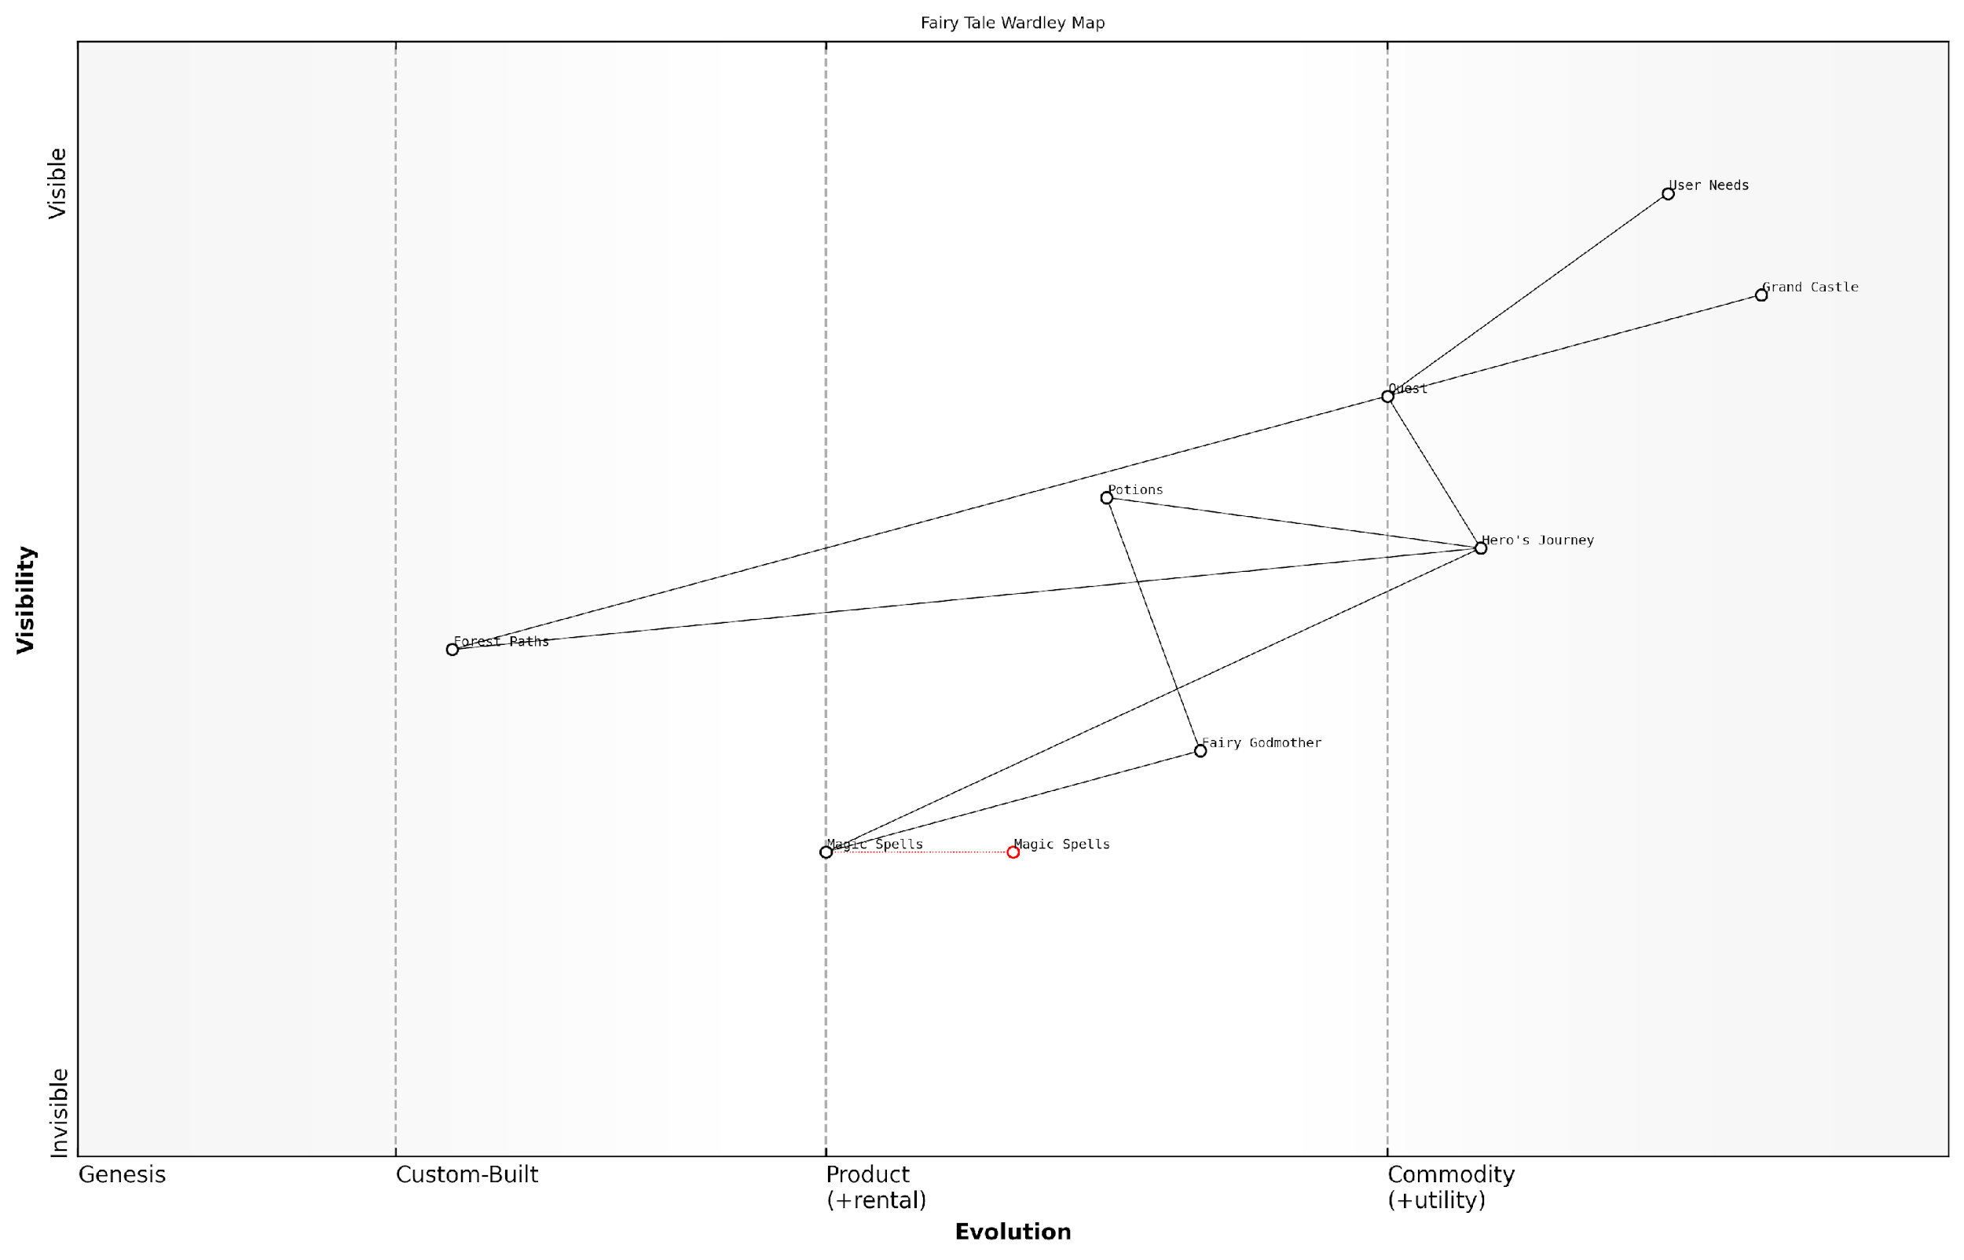

*Draft Wardley Map: [Insert Wardley Map: Key elements of a Wardley Map]*

[Edit this draft Wardley Map](https://create.wardleymaps.ai/#clone:52b59d26a8797537bc)

Wardley Map Assessment

This Wardley Map effectively captures the key elements of fairy tale storytelling, highlighting the progression from foundational magical elements to user satisfaction. The strategic position is strong, with clear value flow and well-positioned components. However, there are significant opportunities for innovation, particularly in evolving the lower-level components like Magic Spells and Forest Paths. By focusing on these areas, it’s possible to create more dynamic, interactive, and personalised fairy tale experiences. The challenge will be to balance innovation with the timeless appeal of traditional fairy tale structures, ensuring that new developments enhance rather than disrupt the core storytelling experience.

[View full Wardley Map report](http://markdown_wardley_map_reports/wardley_map_report_37_Key_elements_of_a_Wardley_Map.md)

### How to apply mapping to any story

Content for How to apply mapping to any story not found.

## Creating Your Own Fairy Tale Map

### Choosing a favourite story

Content for Choosing a favourite story not found.

### Step-by-step guide to mapping

Content for Step-by-step guide to mapping not found.

### Sharing and discussing your map

Content for Sharing and discussing your map not found.

## The Future of Your Mapping Adventure

### Using mapping in everyday life

Content for Using mapping in everyday life not found.

### Continuing to learn and grow

Content for Continuing to learn and grow not found.

# Appendix: Book Generation Details

* Initial Topic: Once Upon a Map: A Child’s Guide to Wardley Mapping Through Fairy Tales
* Refined Topic: Once Upon a Map: A Child’s Guide to Wardley Mapping Through Fairy Tales
* Total Output Tokens: 78246
* Total LLM Cost: $1.17

# Appendix: Further Reading on Wardley Mapping

The following books, primarily authored by Mark Craddock, offer comprehensive insights into various aspects of Wardley Mapping:

## Core Wardley Mapping Series

1. **Wardley Mapping, The Knowledge: Part One, Topographical Intelligence in Business**
   * Author: Simon Wardley
   * Editor: Mark Craddock
   * Part of the Wardley Mapping series (5 books)
   * Available in Kindle Edition
   * [Amazon Link](https://www.amazon.com/dp/B0BVSXB5W5)

* This foundational text introduces readers to the Wardley Mapping approach:
  + Covers key principles, core concepts, and techniques for creating situational maps
  + Teaches how to anchor mapping in user needs and trace value chains
  + Explores anticipating disruptions and determining strategic gameplay
  + Introduces the foundational doctrine of strategic thinking
  + Provides a framework for assessing strategic plays
  + Includes concrete examples and scenarios for practical application
* The book aims to equip readers with:
  + A strategic compass for navigating rapidly shifting competitive landscapes
  + Tools for systematic situational awareness
  + Confidence in creating strategic plays and products
  + An entrepreneurial mindset for continual learning and improvement

1. **Wardley Mapping Doctrine: Universal Principles and Best Practices that Guide Strategic Decision-Making**
   * Author: Mark Craddock
   * Part of the Wardley Mapping series (5 books)
   * Available in Kindle Edition
   * [Amazon Link](https://www.amazon.com/dp/B0C2SFTR7Z)

* This book explores how doctrine supports organisational learning and adaptation:
  + Standardisation: Enhances efficiency through consistent application of best practices
  + Shared Understanding: Fosters better communication and alignment within teams
  + Guidance for Decision-Making: Offers clear guidelines for navigating complexity
  + Adaptability: Encourages continuous evaluation and refinement of practices
* Key features:
  + In-depth analysis of doctrine’s role in strategic thinking
  + Case studies demonstrating successful application of doctrine
  + Practical frameworks for implementing doctrine in various organisational contexts
  + Exploration of the balance between stability and flexibility in strategic planning
* Ideal for:
  + Business leaders and executives
  + Strategic planners and consultants
  + Organisational development professionals
  + Anyone interested in enhancing their strategic decision-making capabilities

1. **Wardley Mapping Gameplays: Transforming Insights into Strategic Actions**
   * Author: Mark Craddock
   * Part of the Wardley Mapping series (5 books)
   * Available in Kindle Edition
   * [Amazon Link](https://www.amazon.com/dp/B0C7CR9R9Q)

* This book delves into gameplays, a crucial component of Wardley Mapping:
  + Gameplays are context-specific patterns of strategic action derived from Wardley Maps
  + Types of gameplays include:
    - User Perception plays (e.g., education, bundling)
    - Accelerator plays (e.g., open approaches, exploiting network effects)
    - De-accelerator plays (e.g., creating constraints, exploiting IPR)
    - Market plays (e.g., differentiation, pricing policy)
    - Defensive plays (e.g., raising barriers to entry, managing inertia)
    - Attacking plays (e.g., directed investment, undermining barriers to entry)
    - Ecosystem plays (e.g., alliances, sensing engines)
* Gameplays enhance strategic decision-making by:
  1. Providing contextual actions tailored to specific situations
  2. Enabling anticipation of competitors’ moves
  3. Inspiring innovative approaches to challenges and opportunities
  4. Assisting in risk management
  5. Optimising resource allocation based on strategic positioning
* The book includes:
  + Detailed explanations of each gameplay type
  + Real-world examples of successful gameplay implementation
  + Frameworks for selecting and combining gameplays
  + Strategies for adapting gameplays to different industries and contexts

1. **Navigating Inertia: Understanding Resistance to Change in Organisations**
   * Author: Mark Craddock
   * Part of the Wardley Mapping series (5 books)
   * Available in Kindle Edition
   * [Amazon Link](https://www.amazon.com/dp/B0C34FX8XC)

* This comprehensive guide explores organisational inertia and strategies to overcome it:
* Key Features:
  + In-depth exploration of inertia in organisational contexts
  + Historical perspective on inertia’s role in business evolution
  + Practical strategies for overcoming resistance to change
  + Integration of Wardley Mapping as a diagnostic tool
* The book is structured into six parts:
  1. Understanding Inertia: Foundational concepts and historical context
  2. Causes and Effects of Inertia: Internal and external factors contributing to inertia
  3. Diagnosing Inertia: Tools and techniques, including Wardley Mapping
  4. Strategies to Overcome Inertia: Interventions for cultural, behavioural, structural, and process improvements
  5. Case Studies and Practical Applications: Real-world examples and implementation frameworks
  6. The Future of Inertia Management: Emerging trends and building adaptive capabilities
* This book is invaluable for:
  + Organisational leaders and managers
  + Change management professionals
  + Business strategists and consultants
  + Researchers in organisational behaviour and management

1. **Wardley Mapping Climate: Decoding Business Evolution**
   * Author: Mark Craddock
   * Part of the Wardley Mapping series (5 books)
   * Available in Kindle Edition
   * [Amazon Link](https://www.amazon.com/dp/B0BVHF2MBH)

* This comprehensive guide explores climatic patterns in business landscapes:
* Key Features:
  + In-depth exploration of 31 climatic patterns across six domains: Components, Financial, Speed, Inertia, Competitors, and Prediction
  + Real-world examples from industry leaders and disruptions
  + Practical exercises and worksheets for applying concepts
  + Strategies for navigating uncertainty and driving innovation
  + Comprehensive glossary and additional resources
* The book enables readers to:
  + Anticipate market changes with greater accuracy
  + Develop more resilient and adaptive strategies
  + Identify emerging opportunities before competitors
  + Navigate complexities of evolving business ecosystems
* It covers topics from basic Wardley Mapping to advanced concepts like the Red Queen Effect and Jevon’s Paradox, offering a complete toolkit for strategic foresight.
* Perfect for:
  + Business strategists and consultants
  + C-suite executives and business leaders
  + Entrepreneurs and startup founders
  + Product managers and innovation teams
  + Anyone interested in cutting-edge strategic thinking

## Practical Resources

1. **Wardley Mapping Cheat Sheets & Notebook**
   * Author: Mark Craddock
   * 100 pages of Wardley Mapping design templates and cheat sheets
   * Available in paperback format
   * [Amazon Link](https://www.amazon.com/dp/B09TPDM9PP)

* This practical resource includes:
  + Ready-to-use Wardley Mapping templates
  + Quick reference guides for key Wardley Mapping concepts
  + Space for notes and brainstorming
  + Visual aids for understanding mapping principles
* Ideal for:
  + Practitioners looking to quickly apply Wardley Mapping techniques
  + Workshop facilitators and educators
  + Anyone wanting to practise and refine their mapping skills

## Specialized Applications

1. **UN Global Platform Handbook on Information Technology Strategy: Wardley Mapping The Sustainable Development Goals (SDGs)**
   * Author: Mark Craddock
   * Explores the use of Wardley Mapping in the context of sustainable development
   * Available for free with Kindle Unlimited or for purchase
   * [Amazon Link](https://www.amazon.com/dp/B09PNKFHG4)

* This specialised guide:
  + Applies Wardley Mapping to the UN’s Sustainable Development Goals
  + Provides strategies for technology-driven sustainable development
  + Offers case studies of successful SDG implementations
  + Includes practical frameworks for policy makers and development professionals

1. **AIconomics: The Business Value of Artificial Intelligence**
   * Author: Mark Craddock
   * Applies Wardley Mapping concepts to the field of artificial intelligence in business
   * [Amazon Link](https://www.amazon.com/dp/B0C6V9VZ9B)

* This book explores:
  + The impact of AI on business landscapes
  + Strategies for integrating AI into business models
  + Wardley Mapping techniques for AI implementation
  + Future trends in AI and their potential business implications
* Suitable for:
  + Business leaders considering AI adoption
  + AI strategists and consultants
  + Technology managers and CIOs
  + Researchers in AI and business strategy

These resources offer a range of perspectives and applications of Wardley Mapping, from foundational principles to specific use cases. Readers are encouraged to explore these works to enhance their understanding and application of Wardley Mapping techniques.

Note: Amazon links are subject to change. If a link doesn’t work, try searching for the book title on Amazon directly.